The 2023 Talmudology
Passover Reader

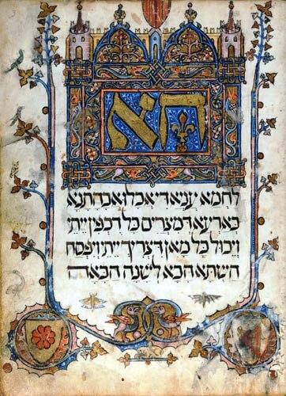

From the Pages of Talmudology.com
The Chemistry of Chametz 2
Blood to Prevent Plague 7
The Passover Seder and the Heimlich Maneuver 9
The Square Root of Two and the Danger of Pairs 16
Roasting the Paschal Lamb and the Maillard Reaction 22
How the Sarajevo Haggadah was Saved. Twice 27
For Discussion at Your Seder:
When Rashi forgot to eat the Afikomen 35
When the Chatam Sofer was banished from his Library. Also Twice 37
May a husband sell his chametz to his non-Jewish wife? 42
Spare a Thought for those who Serve 40
The Ten Plagues – a scientific and historical approach 43

The Chemistry of Chametz

The Talmud in tractate Pesachim discusses the chemistry of chametz:
פסחים לה, א
אמר ריש לקיש וכן תנא דבי ר' ישמעאל וכן תנא דבי ר' אליעזר בן יעקב אמר קרא (דברים טז, ג) לא תאכל עליו חמץ שבעת ימים תאכל עליו מצות לחם עוני דברים הבאים לידי חימוץ אדם יוצא בהן ידי חובתו בפסח יצאו אלו שאין באין לידי חימוץ אלא לידי סירחון

How do we know that matzah must be made from one of five species of grain [wheat, barley, oats spelt and rye]? Reish Lakish said, and likewise a Sage of the school of Rabbi Yishmael taught, and likewise a Sage of the school of Rabbi Eliezer ben Ya’akov taught, that the verse states: “You shall eat no leavened bread with it; seven days you shall eat with it matzah, the bread of affliction” (Deuteronomy 16:3). This verse indicates that only with regard to substances that will come to a state of leavening does a person fulfill his obligation to eat matzah by eating them on Passover, provided that he prevents them from becoming leavened. This serves to exclude these foods, i.e., rice, millet, and similar grains, which, even if flour is prepared from them and water is added to their flour, do not come to a state of leavening but to a state of decay [sirchon].
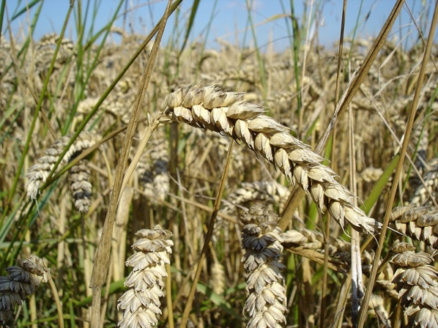
The important question we will answer here is whether there is something fundamentally different about rice when compared to the five grain species that can become chametz. And is there any scientific support to the claim that rice spoils sooner than it ferments?

THE CHEMISTRY OF BREAD MAKING
To get at the answers we need to remind ourselves how plants make and consume starch. They take carbon dioxide from the atmosphere and water from the soil, and using the energy contained in sunlight (and the magic of chlorophyll) convert the two into a large sugar molecule we call starch. Plants use this starch to store and provide them with energy.

If you grind up wheat (or many other species of grain) you make flour which contains loads of starch. In addition to starch, flour contains proteins and enzymes which become important when the flour is mixed with water. Without going down a rabbit-hole of detail, here in general is what happens. First, an enzyme called beta-amylase breaks the large starch molecule down into a smaller molecule called maltose which is made up of two molecules of glucose. Another enzyme, maltase, breaks down each molecule of maltose into two molecules of glucose which is then broken down further to provide the plant with energy.
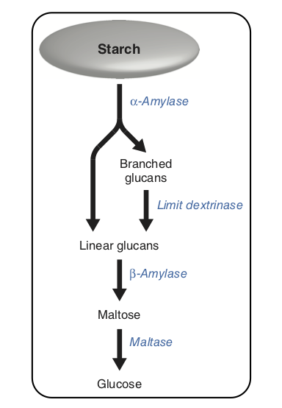
From Lloyd, James R and Kötting, Oliver (July 2016) Starch Biosynthesis and Degradation in Plants. John Wiley & Sons, Ltd: Chichester.

If you add some yeast into that mix, a chemical reaction called fermentation occurs. Yeast, which is a fungus, consumes glucose and turns it into carbon dioxide and ethanol, which is an alcohol.
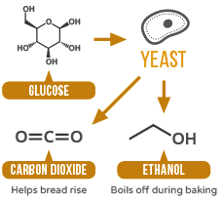

As the flour and water and yeast all mix together, two proteins in the flour called gliadin and glutenin (which are glutens) give the dough mixture its characteristic body, which strengthens the more it is mixed. The dough traps the carbon dioxide that is given off by the yeast cells, which causes the bread to rise. And that gives us the leavened bread we call chametz.

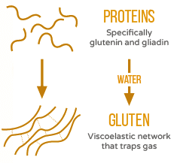

Of course when matzah is made, we do not add yeast to the dough. But there are yeast particles in the air and these will inevitably land on the dough where they will act in the same way, consuming glucose and creating carbon dioxide and alcohol. This process is much slower than when yeast is added when bread is made, but the plain dough will rise a little as a result.

THE DIFFERENCES BETWEEN GRAINS AND RICE
Resh Lakish, together with those sages of the schools of Rabbi Yishmael and Rabbi Eliezer ben Ya’akov claimed that unlike grains, rice does not ferment when water is added to it. Instead it spoils. That’s why it may be eaten on Passover (unless of course you are an Ashkenazi Jew, in which case you still can’t eat it, but for another reason we’re not going to get into). Is this in fact the case?

Dr Angus Murphy is Professor and Chair of the Department of Plant Science at the University of Maryland and wrote the textbook on plant physiology. Dr. Murphy was kind enough to have a long chat with Talmudology over the phone and he agreed with the suggestion that grains and rice do very different things when mixed with water. The wheat seed is surrounded by the endosperm, which is itself covered by the aluerone layer. This aleurone is rich in amylase which as you recall is needed to breakdown starch into glucose (which is eaten by yeast which releases carbon dioxide and alcohol which causes the dough to rise…) However (most species of) rice do not contain this aleurone layer. So they have very little amylase, which means that it takes them a much longer time to convert starch into glucose. In fact, it takes so long that by the time there is enough yeast in the dough for it to start to rise, bacteria in the air will have colonized the mixture and started breaking down the proteins in the dough. And that protein breakdown is what makes the mixture spoil, and which is what the Talmud calls סירחון.

To conclude, Professor Murphy thought that the Talmud’s description of the difference between grain and rice was firmly based in plant biology.

THE FINE PRINT AND THE FINAL VERDICT

Of course things are a little more complicated than that. (They always are.) Different kinds of wheat flour contain different amounts of amylase. Fine bleached white flour contains less amylase than say whole wheat flour, because the aleurone layer in whole wheat flour has not been broken down. Similarly, different species of rice contain different amounts of amylase, so that while standard white rice has very little, brown rice has considerably more. During talmudic times, the wheat flour would have been far less processed than any of the flour we would use today. As a result it would contain more amylase, and would have risen faster than would today’s supermarket flour.

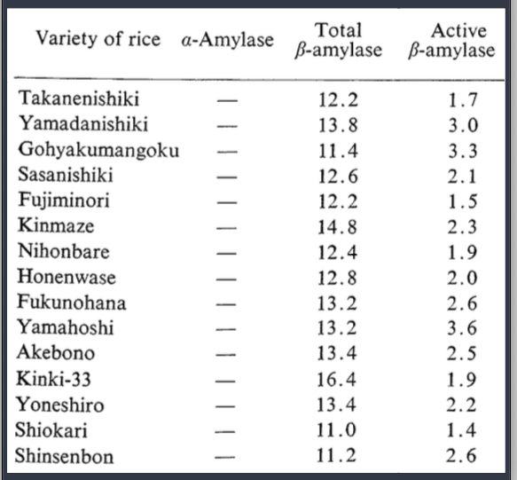
Distribution of various types of amylases in rice grains. (Beta-Amylase activity was expressed in terms of maltose mg liberated in 3 min at 30°C by 1 g of ground rice samples.) From Ryu Shinke, Hiroshi Nishira & Narataro Mugibayashi. Types of Amylases in Rice Grains. Agricultural and Biological Chemistry 1973; 37:10, 2437-2438

But as a rule of thumb, the Talmud is, biochemically speaking, spot on. When mixed with water, the five species of grain from which matzah may be made do undergo fermentation even without the addition of yeast, while rice will spoil long before the fermentation process becomes noticeable.

~

Blood to Prevent Plague

The Mishnah outlines some of the differences between the very first Passover that was celebrated while the Jews were still in Egypt, and the Passovers that were celebrated in the Temple in Jerusalem in the centuries that followed.

פסחים צו, א

מַתְנִי׳ מָה בֵּין פֶּסַח מִצְרַיִם לְפֶסַח דּוֹרוֹת? פֶּסַח מִצְרַיִם מִקָּחוֹ מִבֶּעָשׂוֹר, וְטָעוּן הַזָּאָה בַּאֲגוּדַּת אֵזוֹב, וְעַל הַמַּשְׁקוֹף וְעַל שְׁתֵּי הַמְּזוּזוֹת, וְנֶאֱכָל בְּחִפָּזוֹן, בַּלַּיְלָה אֶחָד. וּפֶסַח דּוֹרוֹת נוֹהֵג כׇּל שִׁבְעָה

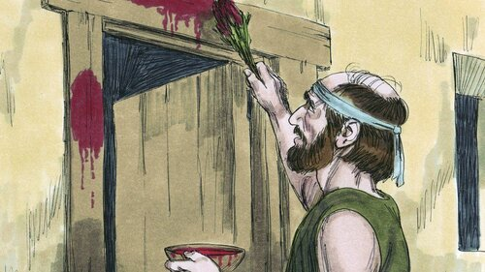
MISHNA: What are the differences between the Paschal lamb that the Jewish people offered in Egypt and the Paschal lamb offered in all later generations? The Paschal lamb the Jewish people offered in Egypt had to be taken from the tenth of the month of Nisan and required the people to sprinkle its blood with a bundle of hyssop, unlike the Paschal lamb in all later years, and its blood was also sprinkled upon the lintel and the two doorposts, and it was eaten with haste; in addition, the Paschal lamb in Egypt was only on one night, whereas the Paschal lamb throughout the generations is observed for seven days.

The Talmud spends several pages discussing the differences between that first Passover and all those that came later. As a rule, we don’t do much sprinkling of blood on our doorposts these days, but that was not always the case. Since we are still in the throes of a pandemic, let’s take a look at an overlooked custom that arose in Turkey during a pandemic there, and how it was connected to this Mishnah.

THE BLOODY QUESTION
Rabbi Chaim Palagi (1788-1868) was an important rabbi and leader of the Jewish community in Izmir (Smyrna), Turkey, and his influence was felt far beyond. Among his many books (somewhere between seventy and eighty!) is a collection of responsa called Chaim Beyad (חיים ביד), in which he was asked the following question:

Come and listen and I will tell you about whether the custom to write God’s name [שם הוי׳ה ב׳ה] with the blood from a circumcision is appropriate. And if it is argued that it is indeed permitted, because it provides protection during an epidemic (heaven forbid), whether it is permitted to write God’s name in red or in any color other than in black ink…

So apparently the Jews of Izmir used to take the blood from a Jewish baby that had just been circumcised paint God’s ineffable name with it onto a flag or poster and presumably hang it somewhere for protection against a pandemic. (I know what you are thinking: why on earth was there so much blood? What exactly were they doing wrong? Fair questions, but let’s stay focused.) This practice had its roots in that very first Passover, where the blood of a lamb painted on a doorpost signaled that there would be no death in the house, for it was under God’s protection.

Rabbi Palagi’s answer is technical and difficult to follow, but in the end he seems to allow the practice if the scribe is “a person of great learning and an expert in Kabbalah and there is a great need.” Moderns would, I am sure, find the whole practice quite distasteful, but it reminds us that when things are desperate and there aren’t a lot of options, prayer and folk magic are invoked in the face of a pandemic. But now, thankfully, we have vaccines.

~
The Passover Seder and
the Heimlich Maneuver

In describing the regulations for the proper performance of the Passover Seder, the Talmud concludes that the celebrant must recline while drinking each of the Four Cups of wine.Then comes this discussion of how, exactly, one reclines:

פסחים קח, א

פְּרַקְדָּן לָא שְׁמֵיהּ הֲסִיבָּה. הֲסִיבַּת יָמִין לָא שְׁמַהּ הֲסִיבָּה. וְלֹא עוֹד, אֶלָּא שֶׁמָּא יַקְדִּים קָנֶה לְוֶושֶׁט, וְיָבֹא לִידֵי סַכָּנָה

Lying on one’s back is not called reclining. Reclining to the right is not called reclining [as free people do not recline in this manner. People prefer to recline on their left and use their right hand to eat, whereas they find it more difficult to eat the other way]. And not only that, perhaps the windpipe will precede the esophagus. [The food will enter the windpipe, and one will come into danger of choking]

Rashi, the great medieval commentator explains that the last comment “perhaps the windpipe will precede the esophagus” refers to lying flat on ones’s back:

רש׳י פסחים קח, א

שמא יקדים - אפרקדן קאי שמתוך שצוארו שוחה לאחריו שיפוי כובע הסותם את פי הקנה נפתח ומתקפל למעלה והקנה פושט למעלה והמאכל נכנס לתוכו ונחנק

This refers to lying on the back. For then the neck is stretched backwards, and the covering that blocks the trachea is open and the trachea is thrust upwards. Food can enter and cause choking.

However, Rashi had a prodigious grandson called Shmuel, who also wrote a commentary on this passage. Rabbi Shmuel ben Meir (c.1085-1158) or Rashbam, as he is known, disagreed with the explanation of his grandfather, and offered this instead:

רשב׳ם פסחים קח,א

שמא יקדים - … וקשיא לי אמאי לא סמכיה להאי ולא אהסיבת ימין ורבותי פירשו שמא יקדים קנה לושט דושט הוי על (דרך) ימין ונפתח הכובע שעל פי הקנה מאיליו כשהוא מטה כלפי ימין ואם יכנס בו המאכל הרי סכנה שאין אוכלין ומשקין נכנסין אלא דרך הושט ולכך נראה בעיני דאהסיבת ימין קאי מדסמכיה לדידיה

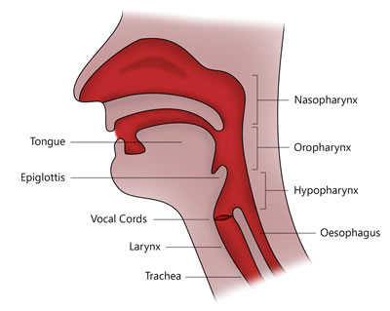
Rashi’s explanation is difficult to understand. Why did he not explain that [the danger] is when you lean to the right [while drinking]? My teachers explained that “perhaps the windpipe will precede the esophagus” refers to leaning, because the esophagus is on the right side. The covering that covers the trachea will open when he leans to the right, and if food gets into the trachea there is a danger [of choking], because food and drink should usually only be found in the esophagus. This is why I believe the Talmud is referring to the [danger of] leaning to the right…

THE RASHBAM’S ANATOMY IS INCORRECT
The anatomy described by the Rashbam is wrong. The trachea lies directly in front of the esophagus; one is not to the right of the other. If you reach up and put your fingers around your trachea now (go on, do it) you will not feel the esophagus because it is lying behind the trachea (and because it is essentially a long fleshy tube with no internal rings for support). This is true in us, and it is true in animals like cows, sheep and chickens, which are kosher and which, presumably, the Rashbam could have used as a model to figure this out. Had he taken a look at freshly slaughtered chicken, he would have seen this.

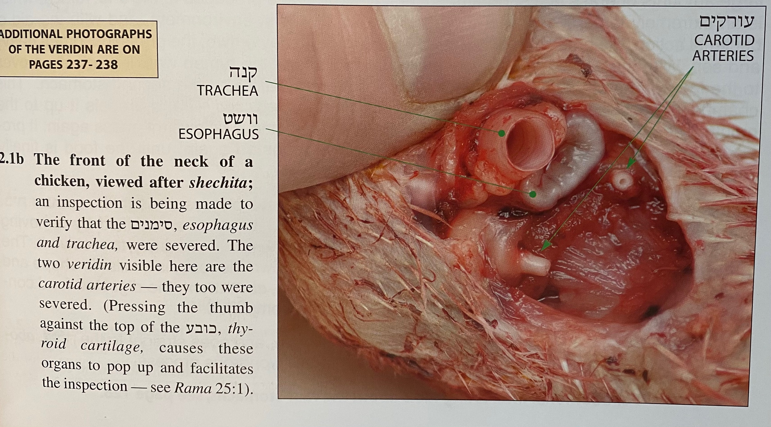
From Yaakov Dovid Lach, Chullin Illuminated. Brooklyn New York. Hamesivta Publications 5771(2011). p35. The trachea clearly lies directly in front of the esophagus, though in the image the latter is slightly off center because of the pressure of the thumb.

WHAT HAPPENS WHEN WE SWALLOW?

The Rashbam did not have access to YouTube, which is a shame, because there are many great videos that explain the process. The epiglottis acts as a trapdoor, closing off the entrance to the trachea each and every time you swallow. Of course when you talk and try to swallow your food, you are forcing air down into the into your larynx while at the same time hoping that no food gets in. When it does, you will cough at best, and choke at worst. Which is why we were always taught never to talk with our mouths full. It’s good advice.

When you choke, a piece of food is stuck around the epiglottis or top of the trachea. This stimulates our coughing reflex, in an attempt to use the force of air to dislodge the food and expel it up and out. If food gets past this sensitive area and enters the lungs, there is no more choking. It is too late for that.

But does leaning to one side or another increase the likelihood of choking on food? Not at all. First, because if you listen to your mother’s advice and don’t try and talk while swallowing, you won’t choke. And second, because the trachea, the esophagus and the epiglottis are all midline structures. Leaning to one side makes you no more or less likely to choke than does leaning to the other.

BUT WHAT ABOUT THE RIGHT MAIN BRONCHUS?

The Steinsaltz (Koren) English Talmud has a nice diagram of the upper trachea and esophagus, but unfortunately it fails to label the all important epiglottis, and nor does it address the issue of the mistaken anatomy of the Rashbam. The Schottenstein (ArtScroll) English Talmud goes into a little more detail. It notes that “actually the esophagus is directly behind the windpipe…which makes it unclear what Rashbam means when he writes that the esophagus is ‘on the right side.’” So far, so good. But then comes this:

There are, though, anatomical differences between the left side and and the right side (e.g the right bronchus branches off the windpipe into the right lung at a far more gradual angle than the left one does into the left lung) that might account for why leaning on the right side presents a choking hazard whereas leaning on the left side does not.

Here is what the ArtScroll explanation is getting at:
.
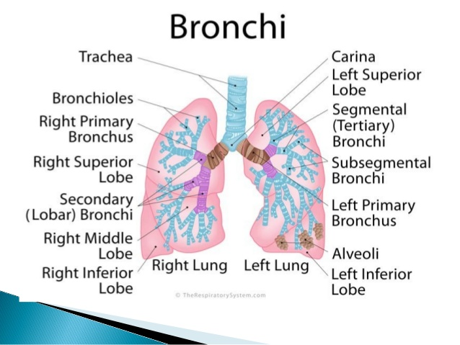

As you can see, the trachea ends at a sort of T-junction with the right and left main bronchi. And if you pay attention to the diagram, you will see that the right main bronchus comes off at a more gentle angle than does the left. Here is another diagram, this time just of the trachea and bronchi, where you can see this a little more clearly:
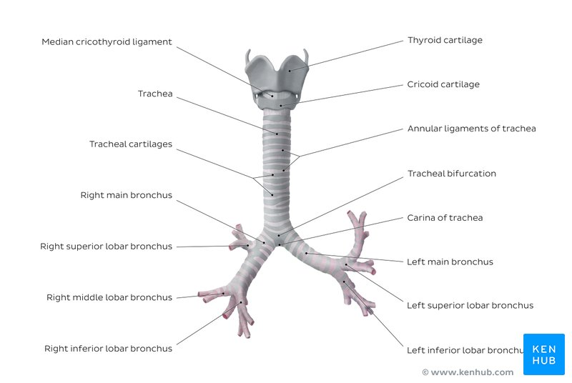

Do you see how, when compared to the left, that right main bronchus comes off at a more gentle angle? Now, if you were a piece of bread, or better yet, a piece of matzah that had snuck past the epiglottis and you were making your way down into the lungs, which direction would you be more likely to go, all things being equal, when you reached that junction with the right and left main bronchi? You would be more likely to continue in a straight line, rather than take a sharp left turn. And so you would be more likely to end up in the right main bronchus. Which is exactly what happens when people aspirate food into their lungs: it generally ends up in the right lung rather than the left. And, by the way you now know the answer to a common question thrown at medical students on the first day of their pulmonary rotations.

But what does this have to do with leaning to the right, as noted in the ArtScroll commentary? In a word, nothing. In two words, absolutely nothing. Leaning to one side or another might theoretically change the side into which the food might lodge of you are unlucky enough to aspirate it, but food in the right lung is as undesirable as food aspirated on the left. Neither is good for you, and if left untreated will lead to aspiration pneumonia and its complications, none of which are good.

WHAT ABOUT A LEFT-HANDED PERSON?
When the Talmud addresses issues to do with sides, it assumes that the person is right-handed, since this is true of the majority. But there are differences for left-handed people. For example, a left-handed person puts tefillin on the right arm, while right-handers do so on the left. Might there be a difference for left-handers when it comes to this business of leaning on the Seder night?

Rabbi David ben Solomon ibn Zimra (1479-1573, known by his acronym Radbaz, was one of the leading rabbinic leaders of his generation. In one of his three thousand (!) responsa he addressed the question of whether a person who is left-handed should recline on his right side. In his answer he wrote that he too failed to understand the anatomy described by the Rashbam.

תשובות רדב׳ז ג: 1012

ועוד ראיתי כי הסימנים שוכבין זה על זה ולא ידעתי אם סימני אדם נשתנה

Furthermore, I have seen that the trachea and the esophagus lie one behind the other (although I do not know if this is the same as in people)

Radvaz wrote that for a left-handed person, leaning to the left would be uncomfortable, and since the entire point of the act of leaning is to replicate a feeling of freedom, for a left-handed person this cannot be the correct thing to do:
ועוד הרי תקנו הסיבה זכר לחירות ואם הוא מסב על ימינו ואוכל בשמאלו מצטער הוא ואין זה דרך חירות
Therefore, he concluded that a left-handed person should lean rightwards, though not because of anything to do with a danger of choking, which, as we have seen, does not depend on leaning one way or the other.

HOW TO SAVE A CHOKING PERSON
According to the National Safety Council, about 5,000 people die in the US each year from choking. About half are over 74, and food is often responsible. This is why each of us should know how to perform abdominal thrusts, also known as the Heimlich maneuver:

- Stand behind the person. Place one foot slightly in front of the other for balance. Wrap your arms around the waist. Tip the person forward slightly. If a child is choking, kneel down behind the child.
- Make a fist with one hand. Position it slightly above the person's navel.
- Grasp the fist with the other hand. Press hard into the abdomen with a quick, upward thrust — as if trying to lift the person up.
- Perform between six and 10 abdominal thrusts until the blockage is dislodged.

So go ahead and learn these steps. Who knows? You might save a life on Seder night.

~

The Square Root of Two and the Danger of Pairs

The Mishnah ruled that a person must drink four cups of wine on the night of the Passover Seder. But this may pose a problem:

פסחים קט, ב

לֹא יִפְחֲתוּ לוֹ מֵאַרְבָּעָה. הֵיכִי מְתַקְּנִי רַבָּנַן מִידֵּי דְּאָתֵי בֵּהּ לִידֵי סַכָּנָה, וְהָתַנְיָא: לֹא יֹאכַל אָדָם תְּרֵי, וְלֹא יִשְׁתֶּה תְּרֵי, וְלֹא יְקַנַּח תְּרֵי, וְלֹא יַעֲשֶׂה צְרָכָיו תְּרֵי

But wasn’t it taught in a baraita: A person should not eat pairs, i.e., an even number of food items; and he should not drink pairs of cups; and he should not wipe himself with pairs; and he should not attend to his sexual needs in pairs.

The rabbis were concerned that doing things in pairs exposes a person to sorcery or demons. Why then would the Mishnah require that an even number of cups be drunk? That would place a person in great danger! Rabbi Nachman provides some reassurance. No harm will come because the night of the Passover Seder is a special night.

פסחים קט, ב

אָמַר רַב נַחְמָן, אָמַר קְרָא: ״לֵיל שִׁמּוּרִים״ — לַיִל הַמְשׁוּמָּר וּבָא מִן הַמַּזִּיקִין

Rav Nachman said that the verse said: “It was a night of watching to the Lord” (Exodus 12:42), which indicates that Passover night is a night that remains guarded from demons and harmful spirits of all kinds. [Therefore, there is no cause for concern about this form of danger on this particular night.]

Additional, or perhaps alternative reasons for reassurance are provided by the great Babylonian sage Rava (c.280-352), and several generations later by Ravina:

רָבָא אָמַר: כּוֹס שֶׁל בְּרָכָה מִצְטָרֵף לְטוֹבָה, וְאֵינוֹ מִצְטָרֵף לְרָעָה. רָבִינָא אָמַר: אַרְבָּעָה כָּסֵי תַּקִּינוּ רַבָּנַן דֶּרֶךְ חֵירוּת, כׇּל חַד וְחַד מִצְוָה בְּאַפֵּי נַפְשַׁהּ הוּא

Rava said: The cup of blessing for Grace after Meals on Passover night is used in the performance of an additional mitzva and is not simply an expression of freedom. Therefore, it combines with the other cups for the good, i.e., to fulfill the mitzva to drink four cups, and it does not combine for the bad. [With regard to the danger of drinking pairs of cups, it is as though one drinks only three cups.]

Ravina said: The Sages instituted four separate cups, each of which is consumed in a manner that demonstrates freedom. Therefore, each and every one is a distinct mitzva in its own right.[In other words, each cup is treated separately and one is not considered to be drinking in pairs.]

THE DANGER OF PAIRS
The Talmud spends several pages (Pesachim 109-111) explaining some of the issues around pairs.

פסחים קי, א

תָּנוּ רַבָּנַן: שׁוֹתֶה כִּפְלַיִם — דָּמוֹ בְּרֹאשׁוֹ. אָמַר רַב יְהוּדָה: אֵימָתַי — בִּזְמַן שֶׁלֹּא רָאָה פְּנֵי הַשּׁוּק, אֲבָל רָאָה פְּנֵי הַשּׁוּק — הָרְשׁוּת בְּיָדוֹ. אָמַר רַב אָשֵׁי: חֲזֵינָא לֵיהּ לְרַב חֲנַנְיָא בַּר בִּיבִי, דְּאַכֹּל כָּסָא הֲוָה נָפֵיק וְחָזֵי אַפֵּי שׁוּקָא.

The Sages taught in another baraita: If one drinks in pairs his blood is upon his head [i.e., he bears responsibility for his own demise].

Rav Yehuda said: When is that the case? When one did not leave the house and view the market place between cups. However, if he saw the marketplace after the first cup, he has permission to drink another cup without concern.

Likewise, Rav Ashi said: I saw Rav Chananya bar Beivai follow this policy: Upon drinking each cup, he would leave the house and view the marketplace.

The great Babylonian sage Abaye (d~337 CE.) was raised never to drink precisely two cups.

פסחים קי, א

וְאַבָּיֵי, כִּי שָׁתֵי חַד כָּסָא, מְנַקֵּיט לֵיהּ אִימֵּיהּ תְּרֵי כָסֵי בִּתְרֵי יְדֵיהּ

When Abaye would drink one cup, his mother would immediately place two cups in his two hands so that he would not inadvertently drink only one more cup and thereby expose himself to the danger of drinking in pairs.

Rav Nachman, who was a contemporary of Abaye, apparently had a personal butler, and followed a similar practice:

וְרַב נַחְמָן בַּר יִצְחָק, כִּי הֲוָה שָׁתֵי תְּרֵי כָסֵי, מְנַקֵּיט לֵיהּ שַׁמָּעֵיהּ חַד כָּסָא, חַד כָּסָא — מְנַקֵּיט לֵיהּ תְּרֵי כָסֵי בִּתְרֵי יְדֵיהּ

And similarly, when Rav Nachman bar Yitzchak would drink two cups, his attendant would immediately place one more cup in his hand, and if he would drink one cup, the attendant would place two cups in his two hands. These reports indicate that one should be concerned for his safety after drinking an even number of cups, even when he remains at home.

ISAAC BAER LEVINSOHN ON THE ORIGINS OF THE SUSPICION

Isaac Baer Levinsohn (1788-1860) was a Ukrainian Hebrew scholar and leader of the Haskalah. In a collection of his essays and letters called Yalkut Rival published in Warsaw in 1878 he addressed the origin of the Talmudic concern about pairs of things. Here it is:

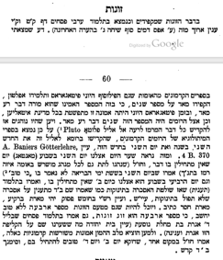
The Babylonian Talmud, Chapter Arve Pesachim, (109–110), expounds at length on the matter of concern about zugot, even numbered events…

In early general literature, I found that both the Greek philosopher Pythagoras and his student Plato were most particular about the number two. They believed that it indicates very bad omen. During the era of Pythagoras, this belief was prevalent over the entire Italian region. The Romans also believed in the terrible powers of the number two. Since they customarily consecrated all evil things to the god Pluto, we find in mythological books of the early Romans that the second month of the year and the second day of that month were consecrated to this god…

Our Sages (who generally sought scriptural hints at established customs) noted [in Gen. Rab. 4:7] that the second of the six days of creation is the only one in which ki tov, “that it is good” [Gen 1:6–8], is not written. We also treat the fourth day of the week like the second day, and do not begin projects on it…

However, it is distinctly possible that the number four is considered to not be good because of zugot, as it is a double pair. Tractate Pesachim of the Babylonian Talmud [112b] also states that on the eve of the fourth day [= Tuesday night] Agrat bat Machlat ventures out (see my Bet Yehudah for speculation as to the original identity of Agrat, the qelipah “shell”). Finally, to defuse these primitive beliefs from the hearts of the masses, our sages maintained elsewhere that Monday and Wednesday are, in fact, excellent days to begin projects, with a mnemonic: Ba”D qodesh, “holy Monday and Wednesday,” literally “holy fabric.”

THE FEAR OF √2
It is not clear to which writings attributed to Pythagoras Levinsohn was referring, but it may be connected to the Pythagorean discovery (if it was indeed discovered by him) that the square root of two is an irrational number. In his sweeping history of mathematics, The Universal History of Numbers: From Prehistory to the Invention of the Computer (p.596) Georges Ifrah wrote that the discovery that √2 is irrational (meaning it goes on and on forever without a repeating pattern, like π) “greatly perturbed the Pythagoreans, who believed that number ruled the Universe…”

The new numbers were called “unmentionable” and the existence of these monsters was not to be divulged to the profane. According to the Pythagorean conception of the world, this inexplicable error on the part of the Supreme Architect must be kept secret, lest one incur divine wrath.

Could this explain the origin of the fear of the number two, and from that the fear of doubles in general?

THE CODE OF JEWISH LAW ON AUSPICIOUS DAYS
In general, Jews are forbidden to pay any attention to superstitions, although as those of you who have spent time studying the Talmud will know, Jews are a superstitious lot. Here is the Shulchan Aruch, the Code of Jewish Law, on the topic:

שולחן ערוך יורה דעה 179

שלא לכשף לעונן ולנחש. ובו י"ט סעיפים

אאין שואלין בחוזים בכוכבים ולא בגורלות: הגה משום שנאמר תמים תהיה עם ה' אלהיך (ב"י בשם תוספות דע"פ ובשם ספרי) וכ"ש דאסור לשאול בקוסמים ומנחשים ובמכשפים

פסקי מהרא"י סי' צ"ו

It is forbidden to turn to astrologers or those who forecast using lotteries. For it is written “You shall be perfect with the Lord your God”

So far so good. But then comes this:

נהגו בשאין מתחילין בב' ובד' גואין נושאין נשים אלא במילוי הלבנה: הגה ולכן נהגו ג"כ להתחיל ללמוד בר"ח כי אע"פ שאין ניח

We have the custom not to begin a project on the second day of the week, or the fourth day of the week

SUPERSTITION IN OUR MODERN WORLD
Our modern, rational world is still filled with superstitions. In the US, at least 85% of buildings using an Otis elevator do not have a thirteenth floor. Actors still say to one another “break a leg” right before a show, reflecting a superstition that wishing an actor “good luck” was…bad luck. And there are any number of superstitions around boats and boating. Pairs and irrational numbers may no longer frighten us but just like our ancestors, we remain a superstition-wary people.

אָמַר רַב פָּפָּא, אָמַר לִי יוֹסֵף שֵׁידָא: בִּתְרֵי קָטְלִינַן, בְּאַרְבְּעָה לָא קָטְלִינַן, בְּאַרְבְּעָה מַזְּקִינַן. בִּתְרֵי, בֵּין בְּשׁוֹגֵג בֵּין בְּמֵזִיד. בְּאַרְבְּעָה, בְּמֵזִיד — אִין, בְּשׁוֹגֵג — לָא

Rav Pappa said: Yosef the Demon said to me: “If one drinks two cups, we demons kill him; if he drinks four, we do not kill him. But this person who drank four, we harm him. There is another difference between two and four: With regard to one who drinks two, whether he did so unwittingly or intentionally, we harm him. With regard to one who drinks four, if he does so intentionally, yes, he is harmed; if he does so unwittingly, no, he will not be harmed.”

פסחים קי, א -Pesachim 110a

~

Roasting the Paschal Lamb and the Maillard Reaction

Spring is just around the corner (unless you are reading this in the southern hemisphere, in which case, please ignore) and barbecue grills are soon going to be fired up. The Kobran Pesach, the Paschal lamb that was offered in the Spring festival of Passover needed a barbecue of its own. It had to be cooked over an open fire, as the Mishnah on this page of Talmud reminds us.

פסחים קטז, א

שֶׁבְּכָל הַלֵּילוֹת אָנוּ אוֹכְלִין בָּשָׂר צָלִי שָׁלוּק וּמְבוּשָּׁל, הַלַּיְלָה הַזֶּה — כּוּלּוֹ צָלִי…

On all other nights we may eat meat that has been roasted or stewed or cooked. But on this night, we may only eat the meat [of the Passover offering] that has been roasted

Earlier in this tractate the Mishnah went into other meticulous details about the permitted cooking process:

פסחים עד, א

מַתְנִי׳ כֵּיצַד צוֹלִין אֶת הַפֶּסַח? מְבִיאִין שַׁפּוּד שֶׁל רִמּוֹן, וְתוֹחֲבוֹ לְתוֹךְ פִּיו עַד בֵּית נְקוּבָתוֹ, וְנוֹתֵן אֶת כְּרָעָיו וְאֶת בְּנֵי מֵעָיו לְתוֹכוֹ, דִּבְרֵי רַבִּי יוֹסֵי הַגְּלִילִי. רַבִּי עֲקִיבָא אוֹמֵר: כְּמִין בִּישּׁוּל הוּא זֶה, אֶלָּא תּוֹלִין חוּצָה לוֹ. אֵין צוֹלִין אֶת הַפֶּסַח לֹא עַל הַשַּׁפּוּד וְלֹא עַל הָאַסְכָּלָא. אָמַר רַבִּי צָדוֹק: מַעֲשֶׂה בְּרַבָּן גַּמְלִיאֵל שֶׁאָמַר לְטָבִי עַבְדּוֹ: צֵא וּצְלֵה לָנוּ אֶת הַפֶּסַח עַל הָאַסְכָּלָא

MISHNA: How does one roast the Paschal lamb? One brings a spit of pomegranate wood and thrusts it into the mouth of the lamb until it reaches its anus, and one then puts its legs and entrails inside it and roasts it all together; this is the statement of Rabbi Yosei HaGelili…

One may not roast the Paschal lamb on the metal spit nor on a metal grill.

The reason that a wooden spit had to be used is that a metal spit would conduct heat to the inside of the carcass and cook it, “and in the Torah it states that the Paschal lamb must be roasted in fire and not roasted through something else [like the heat conducted along a metal spit] (וְרַחֲמָנָא אָמַר ״צְלִי אֵשׁ״, וְלֹא צָלִי מֵחֲמַת דָּבָר אַחֵר).
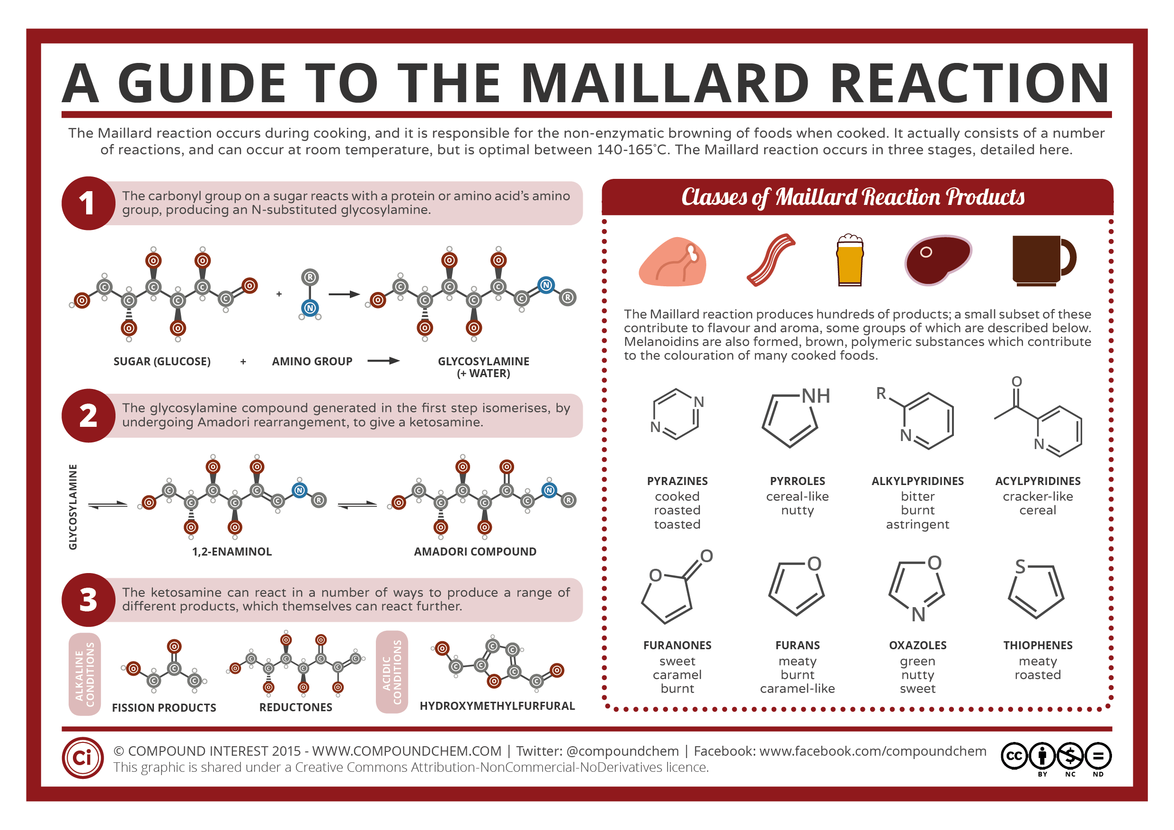
So let’s find out why the roasting process is so special.

ROASTING AND THE MAILLARD REACTION

In 1912 the French biochemist Louis Camille Maillard described a special reaction that occurs only when food has reached a temperature of 280-330F, (140-165C) and if your French is good enough you can read his original description here. What occurs in this special temperature range is that amino acids found in proteins (like meat and fish) react with reducing sugars giving the food its characteristic brown color and special flavor. Maillard uncovered a complex family of reactions, and as noted in Stuart Farrimond’s excellent book The Science of Cooking, these reactions “help us make sense of the many ways in which food browns and takes on flavor as it cooks.” He continues (p 16):

Seared steak, crispy fish skin, the aromatic crust of bread, and even the aroma of toasted nuts and spices are all thanks to this reaction…

Understanding the Maillard reaction helps the cook in many ways: adding fructose-fish honey to a marinade fuels the reaction; pouring cream into simmering sugar provides milk proteins and sugars for the butterscotch and caramel flavors; and brushing pastry with egg provides extra protein for the crust to brown.

As Farrimond the food scientist explains, the temperature needs to reach at least 284F (140C) to give the amino acids and sugars enough energy to react together. At this temperature the proteins and sugars fuse, releasing “hundreds of new flavors and aromatic substances” and the food starts to turn brown. At around 320F (160C) “molecular changes continue and more enticing new flavors and aromas are created…there are now cascades of malty, nutty, meaty and caramel-like flavors.” Now is the time to be careful and pay attention to the temperature, for above about 356F (180C) the food begins to char. This destroys the aromas and leaves acrid, bitter flavors. So “watch the food closely and remove it from the heat before it begins to blacken.”

None of this happens when you boil food, because the boiling point of water (at sea level) is 212F (100C) so all these glorious mouthwatering reactions cannot occur. Let’s pause to think about how some of the other biblical sacrifices were offered, and whether they too underwent the Maillard reaction.

THE BURNT OFFERING (קרבן עולה)
During the Temple period there were other animal sacrifices that were roasted over a flame. One of these was called the Korban Oleh (lit. the sacrifice that goes up), but things didn’t stop with the Maillard process. This sacrifice had to be entirely burned on the altar, (although the skin was saved and given to the Priestly family on rotation that day). Nothing was left of it but charcoal and ashes, which were then shoveled out and disposed of in a ritual of its own. This was a popular sacrifice, which was offered for all sorts of reasons: like recovery from a skin disease, the new appointment of a priest, the completion of a Nazirite's vow, after recovery from skin disease, by a woman after childbirth, after recovery from a state of abnormal bodily discharges, conversion into Judaism or as a voluntary sacrifice, when the sacrificial animal could be a young bull, ram, year-old goat, turtle doves, or pigeons.

THE SIN OFFERING (קרבן חטאת) AND THE GUILT OFFERING (קרבן אשם)
Much of the sin offering (the kidneys, their fat, the entrails and part of the liver) was burned on the altar. Sometimes the entire carcass was burned to a crisp, and sometimes it was left for the priests - the Cohanim - who could eat it under certain conditions (Lev. 6:25-30). Most of these rules also applied to the guilt offering.

THE TAMID OFFERING (קרבן תמיד)
This was offered twice a day, every day including Shabbat. It was also brought on the New Moon (Rosh Chodesh) and on Pesach and Sukkot. Most of it was burned on the altar.

THE “PEACE’ OFFERING (קרבן שלם)
This was a large category of offerings, some for festivals, some by the Nazarite completing his or her term, and some for just saying thanks. Many had to be brought with bread, and much of the animal was burned, though male Cohanim were entitled to eat some parts that remained.

רמבם הל׳ מעשה קרבנות 9:6

וְכֵיצַד מַעֲשֵׂה שְׁלָשְׁתָּן. שׁוֹחֵט וְזוֹרֵק הַדָּם כְּמוֹ שֶׁבֵּאַרְנוּ. וּמַפְשִׁיט וּמוֹצִיא הָאֵימוּרִין. וְאַחַר כָּךְ מְנַתֵּחַ אֶת הַבָּשָׂר וּמַפְרִישׁ הֶחָזֶה וְשׁוֹק הַיָּמִין וְנוֹתֵן הָאֵימוּרִין עִם הֶחָזֶה וְהַשּׁוֹק עַל יְדֵי הַבְּעָלִים וְכֹהֵן מַנִּיחַ יָדוֹ תַּחַת יְדֵי הַבְּעָלִים וּמֵנִיף הַכּל לִפְנֵי ה' בַּמִּזְרָח. וְכֵן כָּל הַטָּעוּן תְּנוּפָה בַּמִּזְרָח מְנִיפִין אוֹתוֹ

What is procedure for bringing these three [types of peace offerings]? [The sacrificial animals] should be slaughtered and their blood should be sprinkled on the altar, as we explained.They are skinned and the portions offered on the altar are removed. Afterwards, the meat is cut up and the breast and the right thigh are set aside. The portions to be offered together with the breast and the thigh are placed on the hands of the owners…

HOW THE KORBAN PESACH DIFFERED
Compared with nearly every other animal scarified in the Temple in Jerusalem, the Passover offering was the only one to be eaten in full by the participants (though the usual bits were offered up on the altar). In fact one of it requirements was that it be eaten entirely. Noting was left over. It was eaten in small family units and everyone had to have at least a little bit. These small groups ensured that everyone would smell and taste the barbecued lamb. Its aroma and taste were very special, for they were the result of the Maillard reaction. No doubt the memory of it all lingered for a long time afterwards, and just as the memory began to fade, it was time to do it all over again.

~

How the Sarajevo Haggadah was Saved. Twice.

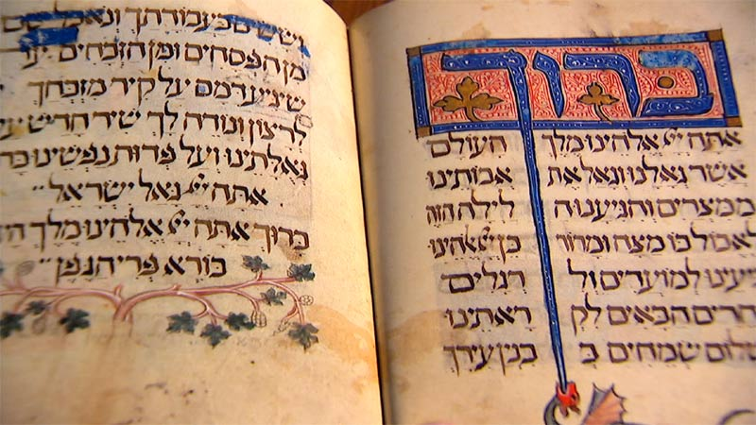

Of all the medieval illuminated Haggadot that exist, the Sarajevo Haggadah is perhaps the most famous. It is thought to have been created in Barcelona around 1350, and today it is on display at the National Museum of Bosnia and Herzegovina. If you are thinking of visiting it at the museum, plan ahead. The Haggadah is on display Tuesdays and Thursdays, and first Saturday of the month from noon to 1pm. You may visit at other times, if you pony up more money and let them know in advance. According to the Museum, the Haggadah is "its most valuable holding," and for good reason. It has three sections: the first has 34 full page small biblical illuminations from the creation of the world to the death of Moses. The next is the text of the traditional Haggadah, and the last section contains poems and readings to be read on each of the seven days of Passover. The illustrations are masterpieces in miniature; deep indigo and red across a golden background, with elegantly elongated Hebrew letters that seem to drip down the page. It is in every way, the gold standard of Haggadot.

THE REMARKABLE HISTORY OF THE SARAJEVO HAGGADAH
We know little of the first five-hundred years of the Haggadah. The name of the original owner is not known, and it appears to have been taken out of Spain in 1492, when Jews were expelled by the Alhambra Decree. There is a note written by a Catholic priest, Giovanni Domenico Vistorini, who inspected the Haggadah in 1609 for any anti-Christian content. Vistorini, who was most likely a converted Jew, found nothing objectionable in the Haggadah. "His Latin inscription, Revisto per mi (“Surveyed by me”)" wrote the Pulitzer Prize winning author Geraldine Brooks "runs with a casual fluidity beneath the last, painstakingly calligraphed lines of the Hebrew text." The Haggadah then disappeared for almost three centuries, until it was sold to the National Museum by a Joseph Kohen in 1894.

“

The Haggada rescue story could, therefore, be placed in the category of verbal communication of a narrow circle of people that share a common past, and in their repeated remembrances of the event, the story becomes rich with new forms and meanings. Such a tale has not yet become a fully formed historical story (legend) as it is known in the theory and history of literature, with the strong likelihood that in the future such a tale may become a standardized verbal communication pattern of past events.

— Kemal Bakaršić. The Story of the Sarajevo Haggada. Judaica Librarianship 1995: 9(1–2); 135-143.

JOZO PETROVIC & DERVIS KORUT SAVE THE HAGGADAH
That the Sarajevo Haggadah had survived that long was highly improbable, but a series of even more unlikely events were to come. On April 16, 1942 the Nazis invaded Sarajevo and immediately destroyed the city's eight synagogues. The director of the State Museum at that time was an archaeologist, Dr. Jozo Petrovic (1892-1967), a Croat from Bosnia. It was Petrovic who was charged with giving a tour to a group of high-ranking Nazis that included the much feared General Johann Fortner. They were looking for the Haggadah to add to their proposed "Museum of an Extinct Race," and during this whole episode, it was in Dr. Petrovic's briefcase. The visit lasted about one hour, and before his departure General Fortner turned to Dr. Petrovic. “Und jetz, bitte, Qbergeben Sie mir die Haggadah!" (And now, please, hand me the Haggadah!)” Geraldine Brooks picks up the story:

The museum director feigned dismay. “But, General, one of your officers came here already and demanded the Haggadah,” he said. “Of course, I gave it to him.."...

“What officer?” Fortner barked. “Name the man!”

The reply was deft: “Sir, I did not think it was my place to require a name.”

Petrovic had come from Belgrade to run the museum, and he was not familiar with local villages and populations. He therefore asked another librarian, Dervis M. Korkut, to move the Haggadah out of Sarajevo. Korut agreed, and (according to one version) he hid it in the mosque of a small nearby village. There an Imam kept an eye on it and returned it at the end of the war. The Haggadah had been saved by brave Muslims.

WHOEVER SAVES ONE HUMAN LIFE...
While the Koruts are best remembered for the role of Dervis in saving the Sarajevo Haggadah, it is not this achievement of which the family is most proud. “In our family, the Haggadah is a detail,” his son said. “What my father did for Jewish people—that is the biggest thing that we, in our family, have to be proud of.”

“

The man so determined to protect a Jewish book was the scion of a prosperous, highly regarded family of Muslim alims, or intellectuals, famous for producing judges of Islamic law.

— Geraldine Brooks. The Book of Exodus. The New Yorker, Dec 3, 2007.

In 1942, shortly after hiding the Haggadah, a sixteen-year-old girl named Mira Papo came to Korut and asked to be hidden. The family took her in, dressed her as a Muslim, and passed her off as their maid. Four months later they arranged for Mira to join her aunt at an area on the Dalmatian coast where there was no Nazi presence. She survived the war and later moved to Israel. And then, in 1994, Mira wrote a testimony of her rescue and submitted it Yad Vashem. Korut Dervis, who had died in 1969, and his wife Servet were added to the names of the Righteous Among the Nations. Servet received a certificate, a pension, and the right to Israeli citizenship.

Just when the story seemed to have reached its conclusion, another dramatic episode began. In 1999, at the height of the atrocities of the civil war in Kosovo, the Korut’s youngest daughter Lamija, and her Muslim husband were forced from their home by Serbian militiamen. They were sent to a refugee camp in which the conditions were so appalling that they were forced to flee. The couple were refused asylum by France and Sweden, and in desperation they turned to the small Jewish community of Skopje in Macedonia. Somehow, Lamija still had with her the certificate that Yad Vashem had given to her mother. She showed it to Victor Mizrahi, the president of the community, and four days later, Lamija and her husband landed in Tel Aviv. The Prime Minister, Benjamin Netanyahu, was at the airport to welcome them. “Today, we are closing a great circle in that the state of Israel, which emerged from the ashes, gives refuge to the daughter of those who saved Jews,” he said. And then, in the chaos of the media frenzy at the airport Lamija heard someone calling her in Serbo-Croatian.

“It was a good feeling, to have someone speaking your language,” she said. But she had no idea who it could be, greeting her so warmly. Pushing through the crowd was a slender, wiry man she had never seen before, with a shock of dark hair and a mustache. Opening his arms, he introduced himself, and Lamija fell into the embrace of Davor Bakovic, the son of Mira Papo.

THE HAGGADAH IS RESTORED
It's a remarkable story, which I hope you will share at your Pesach Seder when you reach the passage שפוך חמתך על הגויים - "pour out Your wrath on the Gentiles who do not know You..." But having taken a deep breath and dried our eyes, let's return to the Haggadah itself. In her 2008 novel The People of the Book, Geraldine Brooks opens in Sarajevo, where, under the watch of staff from the United Nations and security officers from the State Museum, an Australian conservator works on the Sarajevo Haggadah.

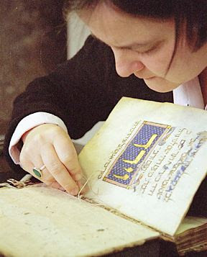
Pataki at work repairing the Sarajevo Haggadah. Photo courtesy of Andrea Pataki.

In fact the real Haggadah did undergo conservation, but it was carried out by Andrea Pataki, from Stuttgart, Jean-Marie Arnolt of Paris, and the late Prof. Bezalel Narkiss, Professor Emeritus of Art History at the Hebrew University. These three experts wrote of their experience in conserving the Haggadah in a paper published in The Paper Conservator in 2005.

Andrea Pataki is a book conservator of world renown. For almost a decade she led the Studiengang für Papierrestaurierung, the Book and Paper Conservation Program at the State Academy of Fine Arts in Stuttgart, before taking up her present position as a professor at the Technical University of Cologne. Pataki is not Jewish, but had lost Jewish relatives in the Holocaust. Recalling her own role in the project, she never considered it significant that she was a Gentile born in Vienna now repairing a manuscript once pursued by the Nazis. Instead, she noted that she was hired because of her expertise and experience. Her own background was of little consequence. And that is how it should be.

In December 2001 Pataki spent nine days repairing the Haggadah at the Union Bank in Sarajevo. Each day, she recalled later in in an academic paper,

... the manuscript was brought to the 'conservation lab' in its metal box which was opened by representatives of the Museum. Working hours were from 8:00 am to 4:00 pm, after which the manuscript was locked in its box and promptly returned to the vault of the Union Bank. As a consequence, it was necessary to stop treatment each day at a stage at which the manuscript could be closed and put away safely. This meant making sure that all repairs would have adequate time to dry during the day, which required a great deal of planning and foresight.

Pataki found that the original covers of the Haggadah, which had certainly been made of vellum, were lost. In their place were cheap cardboard covers in a Turkish floral design, which were entirely orthogonal to the style of the Haggadah. Several sections, called quires, were detached from the rest of the book and needed to be carefully sewn back into place. The book joints, where the outer boards of the cover meet the spine, had broken. This allowed Pataki access to the binding underneath. She repaired one of the four cords that ran vertically down the spine and around which the quires are sewn. The joints were reattached. Finally, she repaired the head a tail caps at the top and bottom of the spine with new calf leather that had been specially dyed for this restoration.

Of all the damage that the Haggadah had suffered, none was more important than the wine stains, just like those found on the pages of family Haggadot to this day. Here is Pataki’s assessment:

The ritual of washing the hands twice during the ceremony had resulted in water stains on the parchment and smudges and smearing of pigments. The ceremony also calls for the drinking of four cups of wine and consumption of different foods dipped in salt water, before and during the festive meal. This activity resulted in many stains and discoloured areas on the pages which call for ritual drinking and eating…

What was to a conservator a sign of damage and discoloration was to the Jewish community a symbol of continuity. The stains were a testament that the Sarajevo Haggadah had not been left on a shelf, but had been used at the table, guiding the Seder night for hundreds of years.

“

Due to the use of the manuscript on the Passover table for many generations, the main damage to the text-block had been caused by liquid.

— Pataki A., Narkiss, B., Arnoult, J. The conservation of the Sarajevo Haggadah, The Paper Conservator, 2005: 29:1, 63-66.

“
THE SARAJEVO HAGGADAH AS A SYMBOL OF TOLERANCE AND HOPE
Neal Kritz, a lawyer at the United States Institute for Peace, was in Sarajevo in the late 1990s. He was part of a delegation that focused on the restoration of the justice system and the atrocities that had occurred during the Bosnian civil war. Kritz recalled how the Bosnian Serbs had demanded the Sarajevo Haggadah be displayed in Banja Luka, the de facto capital of the newly created Serb republic. It was their treasure too, they claimed; it did not just belong to the people of Bosnia-Herzegovina. Their demands were rejected, and the Haggadah remained in Sarajevo, where a new display of it opened there only last month. Kritz received a token of gratitude from the Chief Prosecutor of the Federation of Bosnia-Herzegovnia. It was, of course, a facsimile edition of the Sarajevo Haggadah, which had now come to symbolize efforts to make peace between Bosnians and Serbs. And in November 2017, UNESCO added the Sarajevo Haggadah to their Memory of the World Register to mark, naturally, the International Day for Tolerance.

Over the last seventy years the Sarajevo Haggadah has twice been saved. First, three Muslims risked their lives to rescue it from those who sought to annihilate the Jewish people. And then it was saved from the ruins of time by an expert from the very country from which so much hate had originated. The last word goes to Mirsad Sijarić, the Director of the National Museum of Bosnia and Herzegovina: "The Sarajevo Haggadah is physical proof of the openness of a society in which fear of the Other has never been an incurable disease."

NOTE:
This essay was improved with information provided by Zvonimir Snagic, who identified himself as the great-nephew of Dr. Jozo Petrovic. Petrovic was director of the State Museum when the Sarajevo Haggadah housed there was hidden from the Nazis. Mr. Snagic supplied both testimony from his family and evidence that Dr. Petrovic played at least as large a role in the story as did Devis Korut. We are grateful to Mr. Snagic.

~~~

When RASHI FORGOT TO EAT THE AFIKOMAN
The Machzor Vitry is one of the oldest liturgical texts in Judaism. It contains prayers for the entire year, as well as the customs of the Jews of France, a commentary on the Ten Commandments and Pirkei Avot, liturgical poems, and a whole lot more. It was composed in the eleventh century by Rabbi Simcha of Vitry, a French scholar and student of the great Rashi. Buried deep in the Laws of eating the Afikoman is this:
הלכות פסח, ע״ד. שכח מלאכול אפיקומן
פעם אחת שכח ר' ולא אכל מצה אפיקומן אחר סעודה קודם ברכת המזון. ולאחר ברכת המזון הוזכר. ולא רצה לאכול ממנה. לפי שהיה צריך לברך אחריה ברכת המזון ולשתות מכוס של ברכה. ואי איפשר לשתות בין כוס של מזון לכוס של הלל. דאמור רבנן בין [הכוסות] הללו אם רצה לשתות ישתה בין שלישי לרביעי לא ישתה. ולא רצה לברך עליה ברכת המזון בלא יין לפי שתקנו חכמים כוס שלישי עליה ונראה שהיא צריכה כוס. ואפילו אחר כוס רביעי של הלל לא רצה לאכל מצה ולברך ברכת המזון. מפני שהן לא התקינו אלא ד' כוסות בלבד. אבל חמשה לא התקינו. ועל כן נמנע מלאכול מצה אחר ברכת המזון: והחזיק טעם בדבר זה שאין צריך לחזור ולאכל מצה. מפני שסתם רוב מצות שלנו עשויות כתיקון חכמים ויש בהן שימר לשם מצה. ומצה שאוכל בגמר סעודתו עולה לו לשם מצה של מצוה הואיל ונעשית בה שימור לשם מצה: וכן (נוהג) [נהג] רבינו שלמה מ"כ
Once, R. forgot to eat the Afikoman after the meal, before saying Birkat Hamazon. And after benching he remembered, but didn’t want to go back and eat it.
Who might this mysterious person “R” be? According to Rabbi Zeev Zuckerman, the author of the four-volume set Otzar Pilaos Hatorah, R is none other than Rashi. This makes sense, since Rabbi Simcha ben Shmuel of Vitry (d. 1105) was a student of Rashi. And so we have an eyewitness account that the great Rashi himself once forgot to eat the Afikoman!

But not everyone agrees that “R” was Rashi. Aryeh Goldschmidt published a critical edition of the Machzor Vitry between 2003-2009, and in his commentary he identified R as Rabbi Kalonymous the Elder. This would most likely have been Kalonymus ben Isaac who died in 1126. He was the father of Samuel he-Hasid, and the grandfather of the Judah he-Hasid. Judah was the author of the famous Sefer Hasidim (or at least most of it).

Machzor Vitry, Golschmidt edition. Vol II page 430, footnote 2:
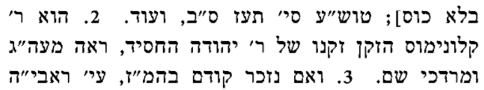
A similar observation was made by Rabbi Mordechai ben Hillel Ashkenazi, known simply as The Mordechai, who was the author of an important legal commentary on the Talmud, and who was murdered in the Rintfleisch pogrom of 1298. Here is his commentary on the Seder, in which he retold the story of Kalonymus forgetting to eat the afikoman:
Sefer Hamordechai. Vienna 1812. 96a.

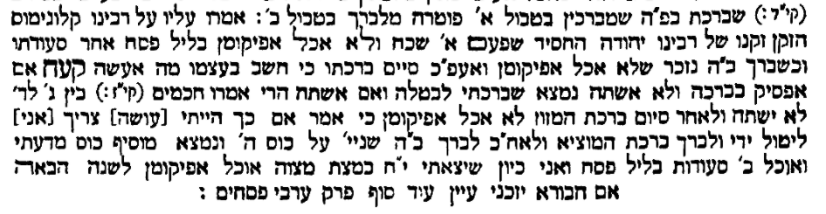

For discussion: Have you ever forgotten a critical part of a Jewish ceremony? How did you feel?
- There are lots of rules to remember and it is easy to mess up. So forgive yourself if you forget something - you are in good company.

WHEN THE CHATAM SOFER WAS BANISHED FROM HIS LIBRARY. BY HIS WIFE. TWICE
The famous Moses Sofer, known as Chatam Sofer, was asked a question by Dayan Yosef Yoel of Ternopil in the Ukraine. The Chatam Sofer gave his answer, but then added this rider:
Chatam Sofer Orach Chaim 136.

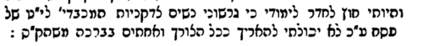

I have no access to my study, for I have been exiled from it by the pious women who are cleaning for Peseach. Therefore, I could not go into further detail, as would have been expected…
Then it happened again. This time the question was from Rabbi Meir of the Hungarian town of Balassagyarmat (Yarmat in Yiddish). And again, Chatam Sofer gave his answer, but once more he was thwarted by the cleaning efforts going on around him.
Likutei Shut Chatam Sofer, 30
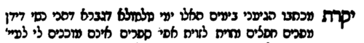

Your dear letter recently reached me, but it is a time of lots of moving, because our women have moved things from here and there, and they don’t even allow me access to my books…
It wasn’t just the Chatam Sofer who complained. Rabbi Yaakov Schorr (1852-1923) who lived in Galicia had similar troubles around the Pesach preparations. In his responsa Divrei Yaakov, published in 1881, he seemed to be losing patience:

Yaakov Schorr, Divrei Yaakov 1881, no 66:

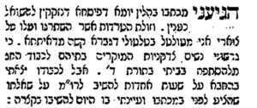

I received your query on these days leading to Pesach, which required you to ask an appropriate question. But I am overworked, as things pile up around my neck, and I am forced to move from place to place. For to be a man is harder than to be a woman (!), for I have been forced out of my home and the Torah of God, by the pious women who are preparing the house for Pesach. But I secretly stole a few hours to answer you…
The great Rabbi Yechezkel Landa of Prague, known as the Nodah Beyehuda was also a victim of Pesach cleaning. His son asked him whether fish brine was chametz. And here is how he began his answer:
Nodah Beyehudah 57.

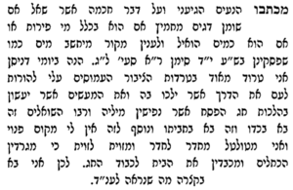

During these days of Nissan I am very busy with the problems of the community, who turn to me with the burden of showing them the proper path forward and how they should follow the many laws of Pesach. One comes with his flask and another with his barrel, and on top of this I have no free place of my own. I wander from room to room and from one corner to another while they scrape the walls and clean the house for Yom Tov. So I must be brief…
Oh, by the way, he ruled that fish brine was indeed chametz. Good to know.
For discussion: There are lots of changes we undertake on Pesach. Do you enjoy them, or find them challenging?
- Just go with it. That’s what the Chatam Sofer did.

SPARE A THOUGHT FOR THOSE WHO SERVE
As we sit down for our seder, we should spare a thought for those whose own seder must be curtailed because they serve others. There are countless nurses and doctors, soldiers and police, ambulance crews and public servants, (and if you are off to a hotel, lots of wait staff, chefs and servers) who continue to work so that we may recline. Sometimes, even rabbis have to give up their seder to serve others. Shmuel Salant (1816-1909) who served as the Chief Rabbi of Jerusalem for seventy years apparently cut his own seder short, so that he could be ready to help others with their halakhic questions on the first night of Pesach.

Rimon Y. and Wasserman Y. Shmuel Bedoro. Tel Aviv. Maslul, 1961. 107.

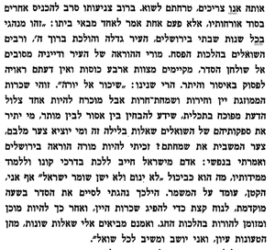

Rabbi Salant was concerned that if he was to drink the four cups of wine, he would not be able to answer any halakhic question that might occur on the Seder night, for a person who has drank wine is forbidden to rule until he sobers up. Consequently, he would have the custom to finish his seder quickly, take a quick nap to sleep off the alcohol, and then wake up ready to answer any questions that might come his way. It’s a charming insight into the life of a public servant, and should remind us to thank all those who toil so that we may enjoy Pesach.
For discussion: There are lots of people who work hard to get us to this night. Spend a moment going around the table to thank them.

MAY A HUSBAND SELL CHAMETZ TO HIS NON-JEWISH WIFE?

Rabbi Yaakov Jacob ben Joseph Reischer (c.1661–1733) served as a dayyan in Prague, and later served in Worms and Metz. Among his three volumes of responsa is this gem:

In the state where I live there is a Jew who married a Gentile. She follows her own customs in every aspect, while he follows the customs of Israel. What happens to the chametz that is found in the house after Pesach? Is it permissible to be used, since it was the chametz that belonged to a Gentile, or is it forbidden, since a wife’s property also belongs to her husband?
Shvut Yaakov vol 1, no 20

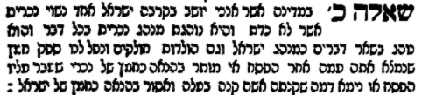

Rabbi Zeev Zuckerman, (from whose work אוצר פלאות התורה, שמות these examples are taken) drew from this responsum an example of the sensitivity with which we should reply to any question, and not disparage the one who asked. I suppose it would have been a better question to ask if a Jewish husband may sell his chametz to his non-Jewish wife, but that wasn’t exactly the question asked of Rabbi Reischer, who ruled that in this case, the chametz was indeed permitted after Pesach.
For discussion: Is there something special about Pesach that resonates with us, even if we are less careful to follow other parts of Jewish practice?
- Always be kind to those with a question about Jewish law.
- And if you are one of those public servants, thank you.

The Ten Plague in Science and History

Excerpted from

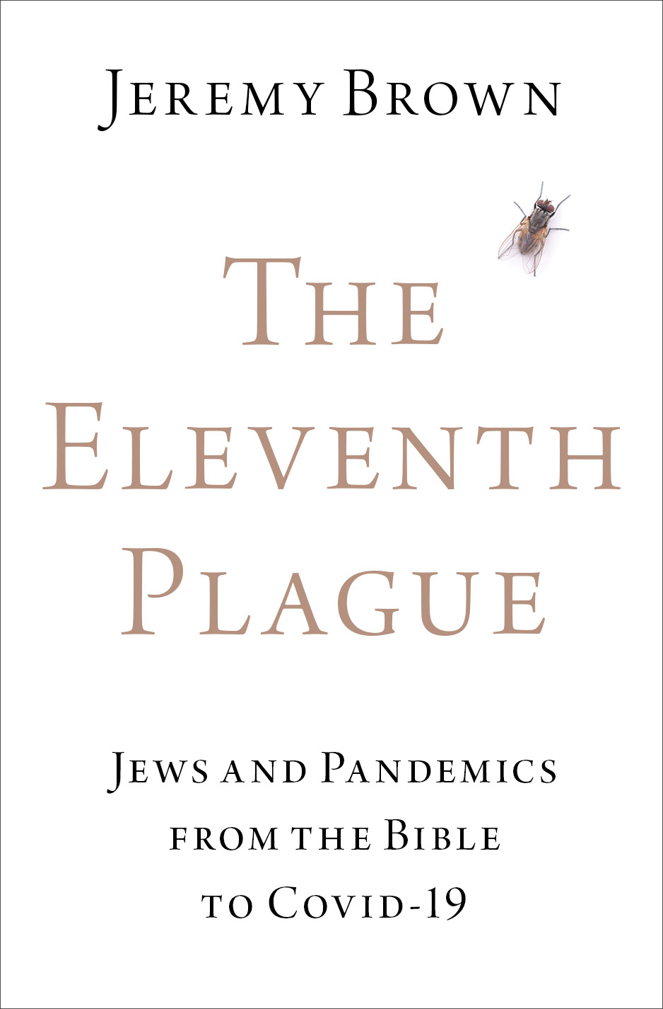
T
he ten plagues are a central part of the story told each year at the Seder. They are counted aloud, then reduced to three groups and counted again. At the mention of each plague, a drop of wine is spilled to demonstrate sadness at the suffering and loss of life that each brought in its wake. There should be no gloating here. But with the distance of time, the reality of a plague, of pandemic disease, was lost on the modern Jew. A little gloating was permitted. It is now possible to buy Ten Plague Finger Puppets (“endless fun for kids and family”), Ten Plagues Nail Decals (“why is this manicure different from all other manicures?”) and Passover Plague Masks (“decorated and designed for that specific punishment”). As we felt increasingly confident in our ability to control pandemic disease, the Ten Plagues were no-longer read and studied for what they really were: an account of pain, disease, and death. Perhaps Mordechai Kaplan and Ira Eisenstein, rabbis and leaders of the American Reconstructionist movement were correct when, in 1941, they published their New Haggadah in which nearly every reference to the Ten Plagues was removed. Apparently, the plagues conflicted with their “highest ethical standards.”

The Many Plagues in the Bible
There are several words associated with plague or disease in the Bible. These include dever, the fifth of the Ten Plagues, as well as magepha, the same word that is used in modern Hebrew to mean pandemic. The Book of Numbers contains four stories of plagues that broke out during the wanderings of the Israelites in the dessert. First, the people complained about the food that God was providing for them: “If only we had meat to eat! We remember the fish that we used to eat free in Egypt, the cucumbers, the melons, the leeks, the onions, and the garlic. Now our gullets are shriveled. There is nothing at all! Nothing but this manna to look to!” In response, God provided an enormous flock or quail “some two cubits deep on the ground” but gave the people little time to enjoy the bounty. “The meat was still between their teeth, nor yet chewed, when the anger of the Lord blazed forth against the people and the Lord struck the people with a very severe plague.” The Hebrew word used here for a plague is makah and not the more commonly used magefah, the term used throughout the Book of Numbers regarding other plagues in the Israelite camp. In fact, in the Book of Numbers the word makah, from the root m-k-h meaning to hit or smite, is exclusively used in reference to the Egyptians. “For every first-born is Mine: at the time that I smote [hakoti] every first-born in the land of Egypt,” God reminds the people “I consecrated every first-born in Israel, man and beast, to Myself, to be Mine, the Lord’s.” The specific use of the term makah here draws the reader’s attention back to the plagues in Egypt, as a reminder that God punishes measure-for-measure. As a result of their lusting after food that they once ate in Egypt, they were smitten with the same form of death – a makah -as that of the Egyptians.

The second instance of a plague in the Book of Numbers is when spies who return with a pessimistic report of land of Israel die in a plague [bamagefah]. A third occurs when followers of a revolt led by Korah were killed in a plague that took “fourteen thousand and seven hundred, aside from those who died on account of Korah.” And finally, a plague was brought by God to punish the Israelites after the men “profaned themselves by whoring with the Moabite women.” In the outbreak (magepha) that followed, twenty-four thousand people died. In the last two instances the outbreaks were brought to an end by the Priests (Cohanim), though in quite different ways. In the plague of Korah, Aaron the High Priest waved incense [ketoret] “as he ran through the camp,” and this ended the outbreak. We will return to this use of incense in chapter eight, and discuss how it became a central theme in Jewish plague liturgy. But the plague that followed the whoring with the Moabite women ended in a far more violent way: Pinhas, the grandson of Aaron took a spear “and stabbed both of them, the Israelite and the woman, through the belly. Then the plague against the Israelites was checked.”

A less well-known word for a plague or pandemic is resheph. In Deuteronomy God warns his people of a “wasting famine, ravaging plague [reshef], deadly pestilence, and fanged beasts” that he would unleash should they fail to heed his words. And Habakkuk warned that “pestilence [dever] marches before Him, and plague [resheph] comes forth at his heels.” For many biblical commentators, resheph denoted some kind of fiery arrow or glowing coal, but its etymology reveals a different explanation. Resheph was a Phoenician and Egyptian god, often associated with war and illness. And some scholars believe that the word dever, which describes the fifth of the ten plagues is actually the name of a demon.

The Ten Plagues
Of the many descriptions of plagues in the Torah, it is the Ten Plagues that is the most well-known. As told in the Book of Exodus these plagues were Blood, Frogs, Lice, Fleas (or Wild Animals, depending on how the Hebrew word arov is understood,) Pestilence, Boils, Hail, Locusts, Darkness, and the Death of the Firstborn. In the first plague, all of Egypt’s water turned to blood. In the second, frogs overran the land. Then there was a nationwide infestation of lice, followed by swarms of larger fleas or insects. Pharaoh still refused to allow the Hebrews to leave, and a plague of pestilence struck down Egypt’s livestock and domesticated animals. In the sixth plague the Egyptians and any of their cattle that had survived to that point were infected with boils. A hailstorm followed, “the likes of which had never been seen in Egypt since it had become a nation.” Huge swarms of locusts then devoured whatever crops were left, and in ninth plague darkness covered the land for three days. Finally, every firstborn male was killed, “from the firstborn son of Pharaoh, who sits on the throne, to the firstborn of the slave girl, who is at her hand mill, and all the firstborn of the cattle as well.” In preparation for this final and decisive plague the Hebrews painted their doorposts with the blood of a lamb, so that God would pass over their homes and leave the inhabitants safe. It is from this act that the festival got its name Passover, or Pesach in Hebrew, which means “to skip over.”

Scientific Explanations of the Ten Plagues

Academic scholars generally do not view the Bible as the word of God given at Sinai. Instead, it is a collection written and edited over hundreds of years, starting around the tenth century B.C.E. and ending sometime in the fifth. What natural events, these scholars have asked, might explain the Ten Plagues? Over the decades there have been a number of different theories, each describing a scenario in which one plague causes the next, and each of which has a rational explanation.

Before discussing these in detail, it is worth remembering that it was not just academic scholars, historians and scientists who used the best contemporary theories to make sense of the biblical account of the plagues. Deeply religious Jewish thinkers did the same long before, though academics would certainly take issue with their conclusions. Perhaps the best example of this is found in the work of Yehuda Ayyash (1688-1760) who lived in Algiers, where he rose to become rabbi of the city. He eventually made his way to Jerusalem although his lengthy work, Vezot Leyehuda [And This is For Yehuda] was published in Sulzbach, Germany in 1776. It includes a commentary on the Passover Haggadah, in which Ayyash asked why, when God threated Pharaoh with the plague of pestilence (dever) the Torah used these specific words: “…the hand of the Lord will strike your livestock in the fields” (Exodus 9:3). It would surely have been obvious that livestock, which generally spend time outside in fields, would be smitten with the plague there, in those same fields. To explain why this location- the fields - was specifically mentioned, Ayyash reminded his readers of the etiology of plagues, or what today we might call their scientific explanations. As we will discuss in detail in later chapters, it was believed that they were caused by foul air, or miasmas, which poisoned those who breathed it. Therefore, when a plague struck, it was best to flee to a place where the air was clean of these poisonous vapors, and this often meant leaving the confines of one’s home and living in open fields.
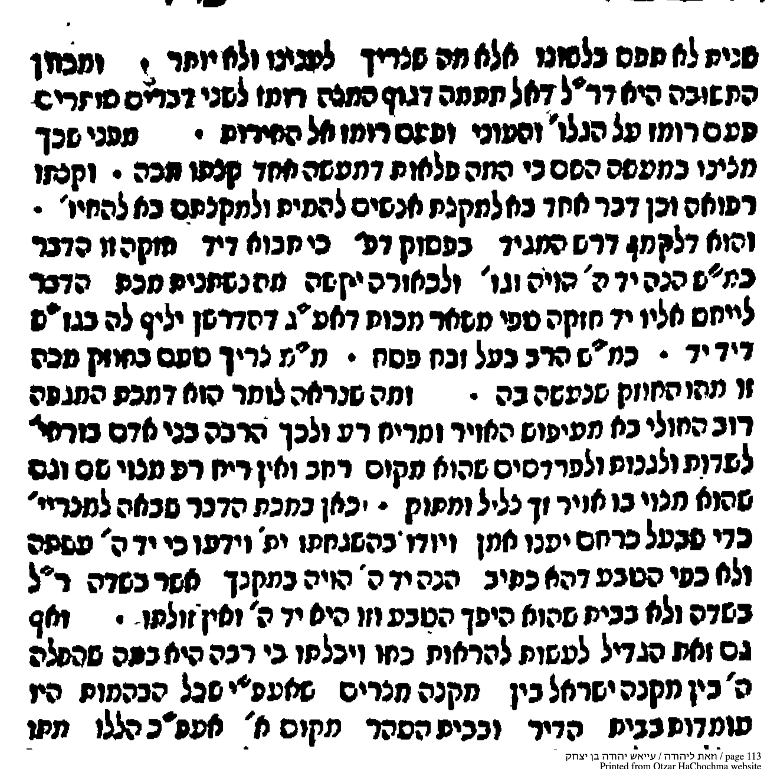

It was important to note that in a pandemic [magefah] most of the sickness is caused by poisonous air and foul smells. Therefore, many people flee to the fields and orchards and meadows, open spaces where there is no foul air, but instead the air is pure and clean and sweet…And it is here that the Egyptians were forced to acknowledge the hand of God and his providence, because they realized that these deaths were not natural…for they occurred in the fields and not inside, which is the opposite of what usually happens. This is the hand of God and there is none like Him.

This account was published some two centuries before a rational etiology of the Ten Plagues became a topic of scientific interest. Now, this deeply religious approach of Rabbi Ayyash might conflict with the methodology of those who would analyze the words of the Bible through a scientific lens. But it demonstrated that even traditional Jews turned to the scientific theories of their time as a starting point for understanding the significance of biblical miracles. Although Ayyash understood the plague of pestilence as a supernatural event and a reversal of the natural order, it could only be comprehended as such using the widely accepted theory of miasmas to explain how it miraculously everted the natural order.

Writing in 1957, Greta Hort suggested that the plagues began with silt that was washed into the Nile from one of its flooded tributaries. The river was overrun with bacteria which caused the fish in it to die. As a result, “the frogs would have to leave their normal biotope and seek refuge on dry land.” However, the frogs themselves died from anthrax, one of those bacteria that bloomed in the Nile. The plague of “lice” was actually a mosquito infestation, and the fourth plague, a swarming of fleas, “is the sudden mass multiplication of some insect or other and its just as sudden disappearance, as it is known to everyone who has lived for any length of time in tropical or subtropical regions.” The decimation of the cattle was caused by their ingesting fodder contaminated with the same anthrax that killed off the frogs. When the anthrax bacillus later infected the Egyptians, it caused the skin pustules described in the sixth plague. Hort’s series of unfortunate events stops at this plague; she postulated that the last four plagues were not interconnected.

More recently, other microbes responsible for the plagues have been suggested. Perhaps it was not anthrax, but by a tiny single-celled protozoon which goes by the scientific name of Trypanosoma evans and which causes disease in cattle, or the rove beetle, which produces a blister-inducing toxin. Perhaps molds played a part. They would have grown quickly in the wet and humid conditions of Egypt’s grain stores, where they released dangerous mycotoxins. In biblical times (and long beyond) firstborn sons were always treated more favorably. Maybe, “during the famine that must have followed the previous plagues, any little food that might have remained inside the houses would have been given to the firstborn. Such food would have been moldy and toxic in view of the rain, hail, and darkness.” In the mold theory, the victims of the tenth plague were killed by the very prejudices of a society that had favored them.

Another telling lays the blame not only on bacteria or molds but on something with which we are all too familiar: Climate change, or more specifically an “unseasonable and progressive climate warming along the eastern Mediterranean coast where Israelites worked in forced labor.” It all began with a change in the weather over the eastern Pacific Ocean, which today we call the El Niño effect. This in turn heated the Mediterranean and the atmosphere over Africa. The Nile waters warmed to a critical temperature, which allowed a massive red algae bloom. This was described as the Plague of Blood. The river then became uncomfortably warm for the frogs, who fled to dry land, where they later died and spread disease. The third plague, lice, was caused by a rise in the population of small insects which enjoyed the unusual wet and humid conditions. Then came the larger fleas and biting flies of the fourth plague “having hatched in soil heavily polluted with animal urine and feces.” The fifth plague which killed Egypt’s livestock was due to infections like the Rift Valley Fever Virus and West Nile Virus, both having been spread by mosquitos which were enjoying the unusually warm and moist climate. Other fly larvae burrowed into the skin and were responsible for the boils which were inflicted on the Egyptians and described in the sixth plague. The last four plagues were also consequences of the El Niño effect. As the warm moist seas air collided with the cooler inland air, violent storms with hailstones resulted. These same storms and high winds then carried huge swarms of locusts into Egypt; as they subsided, a dense fog settled, caused by the sudden condensation of moisture. This was described in the Torah as the penultimate Plague of Darkness. Once again, these conditions were perfect for the mosquitos, which this time spread viral diseases into the Egyptian human rather than the animal population. Older Egyptians would have been immune, having already been infected in previous years but the younger population, which of course included the first born, were not so lucky. In this, the final plague, they died in large numbers.

There is another natural explanation for the biblical plagues in Egypt. Volcanos. This was first suggested in 1940 by a father-son pair of British archeologists who theorized that a volcanic eruption along the rift valley in central Africa led to a series of ecological changes which resulted in the plagues. The theory was criticized soon after its publication not because of its vulcanology but rather its geography: a volcanic eruption in central Africa would send lava south rather than north towards the Nile. This problem was addressed in 1964 when a German researcher suggested a new volcanic site. Around 1600 BCE there had been a massive eruption which destroyed the Aegean island of Thera. It was this eruption, and not one in central Africa, that was the proximate cause of the ensuing plagues. The Aegean eruption was also offered as an explanation of the plagues in a recent book by Barbara Silverstein. It was too far away, she notes, to have been seen in the Egyptian delta, though perhaps the people there “noticed a clattering or shattering of some of their pottery as a wave of air seemed to rush past.” The tsunami that followed the eruption flooded the Delta and contaminated the normal supplies of drinking water. Iron dust from the volcanic eruption settled in the water, and was taken up by iron eating bacteria which in turn excreted large amounts of organic nitrogen. This nitrogen stimulated the “massive growth of toxic dinoflagellates and results in a red tide two or three months after the original dustfall.” It was this that turned the water red. Silverstein further suggested that an echo of the plague of blood might be found in an Egyptian text known as the Admonitions of Ipuwer: “Lo, the river is blood. As one drinks of it one shrinks from people and thirsts for water.”

The contamination of the water left it uninhabitable, and the amphibians were forced to leave, which gives us the plague of frogs. The third plague, lice, was actually a dust storm in which fine volcanic ash reached the Delta. Over the centuries, as the story was remembered and misremembered, the dust from the sky became lice from the ground. “The first light ashfall was not dense enough to produce darkness” Sivertsen explained. “It was only dense enough to be perceived as dust – an acid-bearing dust, irritating the skin of man and beast, like gnats or lice or mosquitos biting. In time, the modifier “like” would be dropped from the oral tradition…and the dust was transformed into small biting insects.” The same oral tradition might have embellished the small insects and turned them into the large flying insects of the fourth plague. That, or the insects swarmed and invaded Egyptian homes as the ash “blocked their tracheal tubes and hindered their ability to fly.” This falling ash killed the livestock that could not be sheltered indoors, and caused the blisters, described in fifth and sixth plagues. This would explain the biblical connection between hot soot and the plague of blisters and boils. “Then God said to Moses and Aaron, "Take handfuls of soot from a furnace and have Moses toss it into the air in the presence of Pharaoh. It will become fine dust over the whole land of Egypt, and festering boils will break out on men and animals throughout the land." The seventh plague of hail was an aggregation of cyclonic storms and ash from the eruption. The next plague, locusts, had nothing to do with volcanos, but was an ordinary, perhaps even expected occurrence in the Egyptian Delta. It was remembered as an especially severe outbreak and was incorporated into exodus story. The ninth plague of darkness is readily explained by the huge clouds of volcanic ash, but rather disappointingly Sivertsen stops here. She makes no attempt to explain the etiology of the final plague, the death of the firstborn “…from the firstborn son of Pharaoh, who sits on the throne, to the firstborn of the slave girl, who is at her hand mill, and all the firstborn of the cattle as well.”

Despite the importance of the Plagues to the Exodus story, nowhere in the Bible are they listed as being “ten.” When they are mentioned in the Book of Psalms, which they are, twice, they are reduced to only seven in number. In Psalm 78, no mention is made of lice and darkness; in Psalm 105 darkness is mentioned as the first plague, not the ninth. This suggests that there had been different traditions about both the number and the nature of the plagues, which were later unified in the account found in Exodus. In light of this, it is difficult to give credence to any of the differing attempts to explain the natural causes and order of the ten plagues, no matter how imaginative they are.

Regardless of which of these highly conjectural explanations might be correct, the authors of the Bible would have described the plagues in terms that would resonate with their contemporaries. Those for whom the story was first written would have recognized many features of the plagues described in the Book of Exodus. They would have nodded their heads at the accounts of lice infestations, skin boils and sudden deaths, for they were also features of their own lived experience. The ten plagues included both natural disasters and epidemics, which, just as they do today, claimed lives in a capricious and random way. The formation of the Children of Israel took place in a crucible of disease.

For the Egyptians of the Bible, the Ten Plagues brought unjustified death and destruction. For the enslaved Hebrews, those same plagues were a sign of God’s loving kindness, and evidence of his compassion for the meek and the subjugated. There is never a single religious response to natural disasters. Their meaning changes with the differing perspectives of those who are either onlookers or victims. Early in the history of America, the colonial settlers evoked the Ten Plagues as an example of divinely ordained disease directed at those with whom God was displeased. Only this time the target was the aboriginal population of the new continent. Starting around 1616 there were outbreaks of pandemic disease that devastated the native Americans. The most likely causes were smallpox and bubonic plague, carried over the ocean by the English settlers. As they watched the destruction of the native population, the pandemic was interpreted as a sign of divine approval. This was exactly the meaning that James, “King of England, Scotland, France and Ireland, and Defender of the Faith” gave to the outbreak in the New Colonies. In December of 1620, just three months after the Mayflower had set sail, the king issued The Charter of New England, which permitted the English settlement and the founding of “several Plantations in the Parts of America, between the Degrees of thirty-four and forty-five.” In the charter, James placed the pandemic into an entirely new context.

We have been further given certainly to know, that within these late years there hath, by God’s visitation, reigned a wonderful plague amongst the savages there heretofore inhabiting, in a manner to the utter destruction, devastation and depopulation of that territory, so as there is not left, for many leagues together, in a manner, any that do claim or challenge any kind of interest therein; whereby we, in our judgement, are persuaded and satisfied that the appointed time is come in which Almighty God, in his great goodness and bounty towards us and our people, hath thought fit and determined that these large and goodly territories, deserted as it were by their natural inhabitants, should be possessed and enjoyed by such of our subjects and people as shall by his mercy and favor, and by his powerful arm, be directed and conducted thither.

The plague was not a natural disaster, but a “wonderful” sign of God’s providence. It was a message that the territories across the ocean rightfully belonged to the king, who could dispose of them as he pleased. And by referring to God’s powerful arm James went still further. After smiting the Egyptians with Ten Plagues, the Bible tells that God took the Hebrews out of Pharaoh’s Egypt to the Promised Land with a “strong hand and an outstretched arm.” This allusion would not have been lost on the biblically literate who read the proclamation of King James. The plague in the colonies was a divine message leading the people, not across the desert to the new promised land, but across the ocean to a land of new promise.

***
One reason for the questionable historicity of the Ten Plagues is the lack of details about them. This allows for a degree of creative interpretation and is exemplified in an attempt to link the Passover tradition to pandemics, particularly bubonic plague. This was the disease that caused the Black Death in the fourteenth century, and which we will discuss in detail in chapter three. Martin Blaser suggested that the celebration of the festival of Passover early in Spring had an important role in public health. The Torah mandated the removal of all leavened bread from the home for seven days and extended this requirement to include not just the Israelite population but resident aliens [gerim] who lived within the borders of Israel. This suggested to Blaser “a purpose beyond religious belief; their inclusion may be interpreted as indicating the danger to the entire community if everyone does not observe this commandment. Thus, in its original meaning, it was important to the Jews that the non-Jews in their midst adhere to this particular requirement, as opposed to many other injunctions in Jewish religious life.” Rodent control is of great importance in preventing outbreaks of bubonic plague, and one way to reduce the threat is to remove their sources of food. “My hypothesis” wrote Blaser in the journal Perspectives in Biology and Medicine

is that these original Passover customs were adaptive for the early Israelite agrarian habitations, in that by requiring an annual spring cleaning of stored grain and grain wastes, they reduced the sites and opportunities for parasitism by grain-eating pests, diminishing exposure of Jews to diseases carried by these pests, especially plague... Passover would be an ideal time to clean grain and wastes from households because of its timing in relationship to the barley and wheat harvests, and its celebration before the usual upsurge in rodent plague activity in the late spring or summer in tropical climes. A thorough removal of grain and grain products from households would reveal signs of rodent contamination and nesting, which could lead to the reinforcement of barriers against such encroachments. Similarly, the loss of rodents' peri-human food source during their springtime peak of multiplication would reinforce the seasonal movement of rodents from human habitations into the fields.

Not surprisingly, Blaser suggested that the tenth of the Biblical plagues was in fact bubonic plague. It did not literally affect only the first-born; instead, it was “a plague of sufficient magnitude to take the lives of one person in three or four (the relative proportion of "first-borns" in the population), including adults as well as children.” Of course, this thesis requires the authors and editors of the Bible to understand the relationship between the rodent population and plague. In the Book of Samuel there does seem to have been some understanding that the two were connected, and an epidemic it describes is so detailed that we are able to identify the culprit with great certainty. It was bubonic plague.

Talmudology is about
Albert Einstein, alcohol, alternative facts, ambergris, amnesia, amputation, amulets, anatomy, androgyny, ants, archeology, asceticism, askera, assisted reproduction, astrology, astronomy, atomic theory, aurochs, Australia, aylonit, bathing, bears, beauty, bed bugs, bees, Ben Ish Chai, Biblical scholarship, bikur cholim, birds, birkat hachammah, bites, blood, bloodletting, blushing, book collecting, breast cancer, breast feeding, bribery, brit milah, British Medical Journal, bullfighting, burial, burns, cesarian section, calendar, Carl Fredrich Gauss, cartilage, caste, cave painting, censorship, chametz, chanukah, Chatam Sofer, Chazon Ish, child abuse, child support, children, chirality, choking, cholera, circumcision, cirrhosis, class, coffins, cognition, Cohen gene, coins, conjugal relations, conversion, cooking, copper, Copernicus, corporal punishment, cows, cranial nerve palsy, crossbreeding, cruelty to animals, cryptorchism, Daf Yomi, David Friesenhausen, David HaCohen, dawn, Dead Sea Scrolls, deafness, disinhibition, divorce, dogs, domestication, Donald Duck, donkeys, dreams, drowning, dukes, dyes, ear candling, ears, economics, Editor of the Talmud, education, electricity, elephants, Ella Fitzgerald, embarrassing, embryology, endoscopy, epidemics, epiglottitis, Eruvin, evolution, execution, Eybeschutz, eye, falls, fetus, fever, fire, fish, flat Earth, flatulence, free will, fun, Galileo, gallnuts, game theory, gangrene, Garden of Eden, garlic, geese scrotum, gender determination, genetics, genital injuries, George Washington, gestation, gonorrhea, gossip, Grady Memorial hospital, gratitude, gynecology, Haggadah, haircuts, halitosis, Halley’s comet, happiness, Hasidim, healing, hell, hematology, hemophilia A, hemorrhoids, hermaphrodite, history vs. heritage, HLA-B27, honey, Hook’s Church Dictionary, hot springs, human dissection, humiliation, hygiene, hymen, ICU, Ig Nobel, incest, incontinence, infertility, infidelity, ink, insignia, insults, intensive care unit, Jastrow, jaundice, Jus primae noctis, kashrut, kedusha, kiddush hashem, King Henry VIII, lasho harah, latrine, lead, leeches, left and right handed, legal liability, Leonardo da Vinci, leopards, levirate marriage, lice, liver, liver disease, logic, Londeon Bet Din, longevity, Lot’s daughters, love, lunar eclipse, lying, Maharal, Maillard, Mar Zutra, marriage marshmallow test, masturbation, maternal imprinting, maternal mortality, mathematics, mechanical engineering, medical students, medicine, Memorex, memory, menstruation, mental illness, mermaids, mesorah, mezuzah, miasma, modesty, Modim, molad, mood, motherhood, mountain heights, mourning, musk, nasolacrimal gland, nazir, Nelson Mandela, neurosurgery, nightmares, Nobel Prize, numerancy, nystagmus, obesity, obstetrics, onanism, ontogeny, open defecation, ornithology, ovulation, oxen, oxytocin, pairs, palm trees, Parliament, parody, Passover, persecution, Pesach, Pew Research, pheromones, philosophy of science, phototherapy, physicians, Pi, Pi Day, pigeons, pigs, pillcam, pimping, plagiarism, plague, plant biology, Pleiades, polycythemia, polydactyly, polypharmacy, prayer for healing, pregnancy, Principal of Contested Sums, probability theory, prognosis, prophecy, prosthetic limbs, Proverbs, puberty, Purim, Pythagoras, Queen Esther, Queen Helena, quincy, Quine, Rabban Gamliel, Rabbi Meir, Rabbi Meir Shapira, Rabbi Yisroel Salanter, Rabbi Yochanan, Rabbi Yossi, rabies, race, Rachel Wolf, rape, Rash, Rashi, Rav Chisda, Rabbi Eliezer Waldenberg, Rav Huna, Rav Moshe Feinstein, Rava, re’em, Resh Lakish, resuscitations, Robert Aumann, Roman gods, roosters, salamander, saliva, Schottenstein, science and certainty, scientific firsts, Sefer Haberit, self-control, shechita, Shimon ben Chalafta, Shmuel, sister-in-law, skepticism, sleep, Slonimski, smell, snails, snakes, sneezing, social isolation, solar eclipse, Soncino, spandrels, speech acts, speed of light, spontaneous generation, statistics, Steinsaltz, Stephen J. Gould, stoning, Sukkot, sin, sunrise, sunset, superstition, Suprem Court, swimming, swordfish, syndactyly, ta’amei hamitzvot, Talmud, talmudic reasoning, techelet, teeth, tekufot, telescopes, ten tefachim, testicles, thanks, Thanksgiving, the Dead Sea, Theory of Disease, Tiberias, toilet paper, toothache, torture, transference, transit of Venus, tree roots, treifut, trephination trigonometry, tumtum, Turner’s Syndrome, twilight, twins, ulcers, urinary tract infections, vaccine denial, vaccines, Vlamadonna Library, venom, vertebral anatomy, virginity, visiting the sick, vows, water, well-being, wine, wolves, Y-chromosome, Yehudah HaNassi, Yom Ha’atzmaut, Zov…and much, much more.

Sign up for new posts and read over 370 topics at Talmudology.com

Happy Passover from Talmudology.com

But the plagues are briefly mentioned. “Then God brought plague after plague upon the Egyptians and upon the land of Egypt; but with each plague, Pharaoh became more and more defiant. Nine plagues failed to move him, but a tenth finally broke his will – every Egyptian first-born was slain. Pharoah, fearing this meant the end for him and his kingdom, hastily relented, and cried frantically to Moses to hurry the Israelites out of the land.” See Mordecai Kaplan, Eugen Kohn, and Ira Eisenstein. The New Haggadah. (Behrman House, 1942), viii, 49- 50.
See also Deut. 28:21.
Numbers 11:4-6.
Ibid 31-33.
See Numbers 13, 17, and 25.
Numbers 3:13. Emphasis added. See also Numbers 8:17 which delivers a similar message: “For every first-born among the Israelites, man as well as beast, is Mine; I consecrated them to Myself at the time that I smote [hakoti] every first-born in the land of Egypt.”
Adriane B. Leveen, "Falling in the Wilderness: Death Reports in the Book of Numbers,” Prooftexts 22, no. 3 (2002): 245-72.
Numbers 14:36-38.
Ibid. 17:11-15.
Numbers 25: et seq.
Numbers 17:12.
Numbers 25:8. See also Leveen, "Falling in the Wilderness" note 9.
Habakkuk 3:4. Some biblical commentators believed that dever and resheph were synonymous. See for example Radak loc. cit. In a fifteenth century German illuminated manuscript a heavenly Christ is shown showering arrows onto humanity below, echoing the prophet’s warning. See “The Plague as Divine Punishment” (1424), Manuscript from the Niedersächsisches Landesmuseum, Hannover. Available at https://www.wga.hu/html_m/zgothic/miniatur/1401-450/7other/01_1402.html. Accessed Jan 24, 2021.
Izak Cornelius. The Iconography of the Canaanite Gods Reshef and Ba'al: Late Bronze and Iron Age I Periods (C 1500-1000 Bce). (Zurich: Vandenhoeck & Ruprecht, 1994) M. M Münnich. The God Resheph in the Ancient near East. (Tubingen: Mohr Siebeck, 2013).
Delbert Roy Hillers, "Demons, Demonology," in The Encyclopedia Judaica, ed. Fred Skolnik (Detroit: Thomson Gale, 2007). 573.
The story of the plagues is recorded in Exodus, chapters 7-11.
Yehuda Ayyash. Vezot Leyehuda. [And This is For Yehuda] (Sulzbach1776) (Hebrew), 58a. Ayyash added another rhetorical flourish: “Another miracle was that even if one of the animals owned by the Israelites was sick or wounded such that it would have ordinarily died, it would instead live, so that the Egyptians would not be able to claim that the plague also affected them [the Hebrews].” (Ibid.)
Greta Hort, "The Plagues of Egypt,” Zeitschrift für die alttestamentliche Wissenschaft 69, no. 1 (1957), 84-103. The natural causes of the last four plagues are described in a second paper: "The Plagues of Egypt,” Zeitschrift für die alttestamentliche Wissenschaft 70, no. 1 (1958), 48-59.
H. M. Hoyte, "The Plagues of Egypt: What Killed the Animals and the Firstborn?,” Med J Aust 158, no. 10 (1993): 706-8. S. A. Norton and C. Lyons, "Blister Beetles and the Ten Plagues,” Lancet 359, no. 9321 (2002): 1950, 1950.
N. J. Ehrenkranz and D. A. Sampson, "Origin of the Old Testament Plagues: Explications and Implications,” Yale J Biol Med 81, no. 1 (2008): 31-42. The authors are careful to explain why the Hebrew slaves themselves were never afflicted. The Bible tells us that they lived separately in Goshen, which “lying beyond the boundary of climate change, would thereby escape all or most plagues.”
John Garstang and J. B. E. Garstang. The Story of Jericho. (London: Hodder and Stoughton, 1940).
See for example Theodor Haster, "The Story of Jericho, by John Garstang and J. B. E. Garstang," Commentary, February 1949.
A. Galanopoulos, "Die Ägyptischen Plagen Und Der Auszug Israels Aus Geologischer Sicht,” Das Altertum 10 (1964): 131-37.
Barbara J. Sivertsen. The Parting of the Sea: How Volcanoes, Earthquakes, and Plagues Shaped the Story of Exodus. (Princeton: Princeton University Press, 2009), 37.
Ibid. 38.
Miriam Lichtheim. Ancient Egyptian Literature: A Book of Readings. Vol 1:The Old and Middle Kingdoms. (Berkeley: University of California Press, 1973) 151. The text was composed between 1500-1000 BCE.
Sivertsen, The Parting of the Sea 39-40.
Exod. 9:8-9.
Exod. 11:4-6.
See for example Samuel E. Loewenstamm, "The Number of Plagues in Psalm 105,” Biblica 52, no. 1 (1971): 34-38.
Cited in Alexander Young. Chronicles of the Pilgrim Fathers of the Colony of Plymouth: From 1602-1625. (Boston: C.C. Little and J. Brown, 1841) 184. The full text of the Charter is available at https://avalon.law.yale.edu/17th_century/mass01.asp.
See Exodus 6:6; Deuteronomy 4:34, 5:15, 7:19, 9:29, 11:2, 26:8 and Psalms 136:12.
Not all the pilgrims felt as comfortable declaring that they understood God’s message. Thomas Hutchinson, who was the Lieutenant Governor of Massachusetts in 1758, seemed at least somewhat ambivalent. “Our ancestors supposed an immediate interposition of providence in the great mortality among the Indians, to make room for the English” he wrote in his history of the colony. “I am not inclined to credulity, but should not we go into the contrary extreme if we were to take no notice of the extinction of this people in all parts of the continent?” Hutchinson strains to interpret the history differently, but he admits in the end that he cannot. The evidence for God’s intervention seems overwhelming. See Thomas Hutchinson. The History of the Colony of Massachusetts Bay, from the First Settlement Thereof In1628. (London: M. Richardson, 1765).
Martin Blaser, "Passover and Plague,” Perspectives in Biology and Medicine 41, no. 2 (1998): 243-56. Marek Tuszewicki from the Institute of Jewish Studies at Jagiellonian University in Krakow has described another Passover related cleaning ritual that was practiced by the Jews of eastern Europe, called parkhe. Its name was a reference to the name Pharaoh (Heb. paroh), the Yiddish word for sickness, parkh or parekh, and one of the Egyptian plagues (‘It shall…cause an inflammation breaking out [pore’ah] in boils on man and beast’; Exod. 9:9). The ritual was usually played out on Shabat Hagadol (the sabbath before Pesach), and involved young men roaming the streets of their town looking for fellow residents with skin diseases such as mange- though any bald or balding med would do just as well. Anyone who answered to the description would be regaled with the irreverent rhyme Halelu, halelu min hashamayim, kol haparkhes lemitsrayim (Glory, glory from heaven, all the scab-heads to Egypt), and presented with a train ticket accompanied by the recommendation that they pack their bags quickly because the train from Budzanow (or whatever their town was called) to Egypt would not be waiting long. This ‘leper-hunt’ would often take the form of a procession with drums and other instruments, and, carried at its head, a straw figure dressed for a journey (in trousers, overcoat etc.). In some places ‘leper lists’ would be displayed in public, in either alphabetical or hierarchical order, with a list of what the exiles would need for such a long journey: a pot of chicken broth, pickled gherkins, and a comb.” Marek Tuszewicki. A Frog under the Tongue: Jewish Folk Medicine in Eastern Europe. (London: The Littman Library of Jewish Civilization, 2021)181-182. Unfortunately, Tuszewicki does not provide a reference for this observation. I am grateful to Erica Brown for bringing this book to my attention.

